CHAPTER 1 INTRODUCTION TO THE STUDY

Background of the Study and Theoretical Framework

Tourism is seen as one of the most sustainable economic growth strategies for cities. Especially after the last global economic crisis, it was perceived as a significant driver for economic recovery or growth. Until recently, during the surge of COVID-19, the Philippines reported a decline in foreign visitor arrivals starting in mid-year due to the closure of the country’s borders.

However, the Philippines’ local tourism industry rebounded after two years as the demand for domestic travel soared amid the pandemic, according to the Department of Tourism (DOT). Based on the 2021 Philippine Tourism Satellite Accounts (PTSA), domestic trips in the country totaled 37,279,282, or 38.16% higher than 2020’s 26,982,233.

Included in the report, tourism's contribution to the country's economy is defined as the Tourism Direct Gross Value Added (TDGVA), generated by tourism industries and other sectors of the economy that directly serve visitors in the Philippines (PSA, 2022).

This progress is associated with the Sustainable Development Goal No. 8, Indicator No. 9 led by the United Nations (UN), World Trade Organization (WTO), and World Tourism Organization (UNWTO) that aims to devise and implement policies to promote sustainable tourism that creates jobs and promotes local culture and products towards the progress of the economy (SDG Goals). Consequently, some cities and provincial governments in the Philippines welcomed visitors and tourists locally. These procedures are made possible by Local Government Units (LGUs) and are accompanied by the proper strict implementation of health and safety measures.

Included among these cities is Iloilo, strategically located in the country and Western Visayas, making the city the preferred destination for meetings, incentive travel, conventions, events, and investments as well. Iloilo City's tourism is one of the important sectors that contribute to the development of its community and economy in the region. It became one of the pacesetters in preserving both old and new infrastructure as popular destinations for tourists, locally and internationally. As the course of the pandemic

hits worldwide, the number of tourists dropped by 186,980 with 179,299 domestic tourists (95.89%) and 7,234 international tourists (3.87%) last year. Whereas, international arrivals in 2021 are higher with 15,973 (7.54%) of tourist data and for domestic arrivals toned down to 195,941 (92.46%).

The Iloilo City Tourism and Development Office, which is responsible for providing these statistical reports, began their electronic data gathering with the utilization of Microsoft products, in particular, MS Excel. To this day, the number of tourists is still collected through a monthly visitation by selected personnel in every lodging establishment, such as hotels, inns, and pension houses. Each establishment, including tourist attractions, performs a manual logbook system for tourists and visitors to monitor the visits alongside distributing survey forms printed on paper. The survey form is composed of basic information and exclusive questions to ask each visitor and tourist about their stay and experience at a tourist attraction. Moreover, the survey form has been widely recognized by the office to be essential in gathering feedback for festivals and events

with minor changes towards the basic information as this involves the Data Privacy Act of 2012 to safeguard tourists' identities while traversing in and out of the city.

Unfortunately, this initiative reruns inconsistently throughout the years. Most of those in charge of these tourist attractions have followed an incoherent procedure for distributing survey forms, making them inaccessible and difficult to collect by hand. The handwriting mechanism causes disarray for encoders and some confusion about the possibility of typing false information when gathering data on tourists and visitors. This problem was also raised by the office during COVID-19 in accordance with strict implementation and safety precautions for travelers who started visiting some tourist attractions for the reason that basic information is vital to track and contact people when a positive case has been reported in the said place. Although the implementation of ICT and tourism is made possible by secondary software, some circumstances happen primarily due to remote data collection between the tourism offices and tourist attractions, which causes delays and incessant inconvenience in producing annual reports.

To answer these challenges, critically assessing the foundations of ICT and Tourism is thus paramount. (Leal et al., 2020) discuss that tourism platforms do collect reviews or reservations data to identify business trends, to monitor businesses and tourists, and to predict tourist behavior through a series of crowdsourcing components. Additional authors argue that such a redesign of these applications will hold platforms accountable, and increase trust in business- to-platform, tourist-to-platform and business-to-tourist relationships (Gössling, 2020). Hence, gathering the number of tourists alongside with the crowdsourced data including feedback and review of each tourist attraction automatically, it would lead the tourism office to work at ease.

This study aims to develop a crowdsourced-based mobile application for local tourist attractions exclusively in Iloilo City. It will address the issue concerning the inaccessibility of the Iloilo City Tourism and Development Office to gather personal sentiments of tourists during their stay in Iloilo and its tourist attractions. Furthermore, sentiment analysis will be used to generate whether the crowdsourced data is positive or negative feedback and can be

easily detected by tourists if a tourist attraction is a safe place to visit at a glance.

As mobile applications have been developed to better give aid to tourists in satisfying their particular requirements and in ensuring a more efficient use of time than web applications, they have increasingly tended to adopt intelligent guide systems designed to exploit new technologies to support them in the planning of their trips, thereof, accompanied with crowdsourced feedback and location information.

Theoretical Framework

This study is anchored on the *Theory of Taxonomy and Dimensions of Crowdsourcing* by Hobfeld et al. in 2013. According to this theory, the purpose of taxonomy is not to achieve automation, but rather to provide good guidelines for the design and development of crowdsourcing tasks and campaigns. According to this theory, the five major dimensions of crowdsourcing for each task are (1) who, (2) where, (3) why, (4) what, and (5) how.

1. Who. A more specific question is what type of crowd is present. In this dimension of crowdsourcing, the actual performers performing the task are distinguished. A crowd required for a specific task can be described in terms of anonymity, the number of (reliable) performers, the crowd's social structure and prior relationships between performers, diversity of performers (in terms of cognitive, cultural, gender, or personal bias), trust, and the communication structure within the crowd. Also consider other individuals or parties involved in the crowdsourcing process, such as (a) employers, task assigners, or promoters, (b) beneficiaries, or (c) platform providers. This implies that the entire stakeholder structure must be considered.
2. Where. Another dimension is the task's location or context, as well as the crowdsourcing platform and the performers. The context in which the task is carried out may be important for crowdsensing. It must, however, be distinguished between a physical location and context. The crowdsourcing platform used must also be taken into account, as it brings in not only its own crowd, but also certain mechanisms that may affect the crowdsourcing task design.
3. Why. A taxonomy is relevant to the incentives provided by the task and its execution. As a result, motivational diversity must be considered. Examples include money as provided by commercial platforms, fame and reputation, e.g., for open-source implementation, learning, i.e., the performer wants to benefit from executing the task by gaining new knowledge, e.g., for open-source implementation, altruism, such as social responsibility, and side effects, such as ReCaptcha, where the actual task does not bring any incentives, but the task has to be conducted e.g., in order to get access to download software.
4. What. This dimension captures the type of goal or problem that will be solved by the task. This includes the following aspects, size of the task itself which may vary from contests to micro-tasks and therefore may require different mechanisms and design approaches, type of activity covering human computation, sensing, information foraging, evaluation, creation e.g. software or logo design, stopping condition of a tasks, i.e. whether the employer knows when the campaign is really done, possibility of evaluating the quality and reliability of the submitted results, level of

engagement of the performer which may be high e.g. crowdfunding, medium e.g. do something, or low e.g. sensing which is done by the user’s device in the background, degree of control.

1. How. This dimension encompasses a wide range of aspects concerning how the task is actually designed and carried out. This dimension differs on a higher level between
2. the method, mechanisms, or solution architecture as well as (B) the types of coordination mechanisms. Examples for coordination mechanisms are aggregation of users from different platforms, of user results, and of tasks to macro- tasks, selection of users or sub-tasks, scheduling of the sub-tasks, or resource allocation in terms of cost, time, and human efforts.

The methods, mechanisms, or solution architectures address the task's degree of specificity, degree of control, locus of control, and approach. These five dimensions, Who, Where, Why, What, and How, provide a basic framework for a crowdsourcing taxonomy that may lead to useful guidelines for the design and development of crowdsourcing tasks and campaigns.

Overview of the Current System and Related Studies

*Current System*

Annually, the Department of Tourism - Region VI (DOT- Region VI) holds meetings for the Iloilo City Tourism and Development Office together with other Regional Tourism and Development Offices to validate the performance of each city or province in the tourism sector every year. This activity will be presented during the Philippine (Meetings, Incentive Travel, Conventions, and Exhibitions/Events) M.I.C.E Conference and the following tourism conventions supported by the Department of Tourism (DOT) in the national area and the Tourism Board of the Philippines (TBP). The report includes quantitative metrics such as the number of tourists with their gender, age, and country (if, international) or province (if, local) and is categorized per month. The data is collected from accommodation establishments including hotels, inns, and pension houses based on logbook systems, or in such cases, a hotel management system (HMS) for the finest hotels.

Selected personnel from the Iloilo City Tourism and Development Office visit these tourist attractions and

establishments every month, and the data is both received by email or printed form through an Excel file. The said data is updated annually and can be retrieved at any time as it requires to be approved by the DOT. The overall report is analyzed and submitted to the Philippine Tourism Satellite Accounts (PTSA), which is co-headed by the Philippine Statistics Authority (PSA).

The said survey forms are compiled directly through an Excel spreadsheet (.xlsx file) and the Iloilo City Tourism Office holds an annual meeting to discuss and identify the huge number of feedbacks as this aids the deployment and development of the tourism industry in the city.

*Related Systems*

*Waze.* The largest community-based free traffic and navigation application. Waze utilizes floating car data (FCD) obtained from the driver’s or passenger’s smartphones in order to generate real-time traffic information similar to Google Maps. Even though the main purpose of the Waze application is to facilitate user’s vehicle navigation, it also gives users the provisions for manipulating maps (e.g.,

adding new roads, reporting hazards and potholes). Just like Google Maps, Waze works upon the simple request/response protocol principle where the smartphone client application sends periodic messages to the Waze server with its current position acquired through the phone’s GPS receiver. Subsequently, the Waze server returns the navigation plan together with the traffic information along the planned route in a response message. Since Waze is a community-driven approach, it generally requires the user to register before using the app. Once the user logs into the system, an appropriate Waze server ID is returned with a cookie, which is used to differentiate the individual user session for subsequent request messages. Waze incorporates crowdsourced sensor data in a limited manner for outdoor navigation map manipulation purposes only, but does not address the indoor map construction-related challenges (Hossain, 2019).

The similarity between the Waze app and the proposed system is that both used crowdsourcing to gather information from users and the Global Positioning System (GPS) to navigate the user’s location. The difference is that Waze solely focuses on traffic management, and the feedback collected

through crowdsourcing has no sentiment analysis, whereas the proposed system focuses on tourism performance management, sentiment analysis and has an exclusive check-in feature.

*Google Maps.* Google Maps is a mobile and web service that provides detailed information about geographical regions and sites worldwide. In addition to conventional road maps, Google Maps offers aerial and satellite views of many locations. Along with Google Reviews, users can accessibly write reviews for places whether it's near or far from the location of a user. Even though Google Maps, Places, and Routes APIs are free for a number of use cases, its full functionality access requires a licensed version. Each of these Google Maps products includes a set of APIs and SDKs with 200 USD free monthly usage. If usage exceeds this free credit, customers are charged based on their consumption. Crowdsourcing was initially considered unimportant by Google Maps during the build of a US proprietary database, which was constructed by acquisition of maps from the authoritative or trusted state, regional and city sources. However, crowdsensing is then used as the main agent for the revision

of the map database worldwide, which has recently been discontinued.

The similarity between the Google Maps application and the proposed system is that both use the Global Positioning System (GPS) as well. However, although the Google Maps application gathers reviews based on personalized star ratings, the proposed system will automatically convert the crowdsourced information into a sentiment classification, either positive or negative, which is useful for tourists if it's recommended for them to visit a certain place.

Objectives of the Study

This research generally aims to develop a mobile crowdsourcing-based application for local tourist attractions with sentiment analysis.

Specifically, it aimed to:

* 1. Collect feedback from tourists as data to visit based on their experiences using crowdsourcing;
  2. Implement sentiment analysis to classify tourist’s crowdsourced information as positive or negative using Tensorflow Lite;
  3. Deploy a heat map based on sentiment analysis that can assist tourism officers to identify which tourism destinations are in need of improvements using Mapbox;
  4. Generate analytics reports including quantitative tourism visits and qualitative tourism review using sentiment analysis; and
  5. Evaluate the functionalities and efficiency of the system based on ISO Software Evaluation Standard.

Significance of the Study

The results of the study may be beneficial to the following groups of people:

The *Iloilo City Tourism Office* may benefit from this study and the results of the study may be used to give them an understanding of which programs and initiatives to uphold in the community and may help the development of the city.

The *Related Businesses and Small Medium Enterprises near Tourist Attractions* may benefit from this study and the results of the study may be used to give them knowledge on what’s happening towards the tourism industry and how this contributes to Iloilo City’s enriching economy.

*International and Local Tourists* may use the results of this study as a reference on what action they may do to improve the accessibility of tourism offices so that the foreign tourist may reach them directly.

*The future researchers* may use the findings of this study to serve as a reference material and a guide to conduct the same study or any study related to this field. Furthermore,

the findings of this study may serve as a reference for future researchers, allowing them to avoid the challenges faced by the current researchers and perform a study based on the unanticipated gaps of this research study.

Definition of Terms

For better understanding, the following terms were defined conceptually and operationally:

*Check-In-* the act of recording your arrival at a hotel or at an airport when you are going to travel. In *dictionary.cambridge.org.* Retrieved November 10, 2022, from (https://dictionary.cambridge.org/us/dictionary/english/che ck-in)

In this study, it was used as a term of recording the arrivals of the tourist in the said tourist spot.

*Crowdsourcing-* a process of getting work done by a crowd of people, i.e., it corresponds to any collective and collaborative activity performed by a large number of volunteers via information and communication technologies (Howe, 2006).

In this study, it was used as a process of getting feedback and comments from the tourists with the use of a crowdsourced mobile application.

*Cultural-* refers to the way of life and attitude towards each other. In Cambridge.org. Retrieved October 11,2022,from([https://dictionary.cambridge.org/us/dictionary](https://dictionary.cambridge.org/us/dictionary/english/cultural)

[/english/cultural](https://dictionary.cambridge.org/us/dictionary/english/cultural)).

In this study, cultural is used as a traditional or historic site and landmark.

*Global Positioning System (GPS)-* a navigation system using satellites, a receiver and algorithms to synchronize location, velocity and time data for air, sea and land travel (Team, 2022).

In this study, it was used as a navigation system to

navigate the tourist’s location

*Internet-* a worldwide system of computer networks -- a network of networks in which users at any one computer can, if they have permission, get information from any other computer. In *techtarget.com.* Retrieved March 8, 2022, from [(https://www.techtarget.com/whatis/definition/Internet).](http://www.techtarget.com/whatis/definition/Internet))

In this study the internet was used in order for the users to connect to the website.

*Location-* the place where a particular point or object exists. Location is an important term in geography, and is usually considered more precise than "place”. (Evers, 2022).

In this study, location refers to a place where the tourist spot was located.

*Man-made*- artificial made or produced by the people rather than nature. In *Britannica.com.* Retrieved October 11, 2022, from [(https://www.britannica.com/dictionary/manmade).](http://www.britannica.com/dictionary/manmade))

In this study, man-made objects are used as tourist destinations in Iloilo City such as museums.

*Map- a* symbolic representation of selected characteristics of a place, usually drawn on a flat surface. Maps present information about the world in a simple, visual way. In National Geographic Society. Retrieved November 9, 2022, from

[(https://education.nationalgeographic.org/resource/map](https://education.nationalgeographic.org/resource/map)).

In this study, a map is used as a visual representation of a land or area where the tourist spot is located.

*Sentiment Analysis-* refers to the use of computational linguistics and natural language process (NLP) to analyze text and identify its subjective information (Brob, 2013).

In this study, Sentiment Analysis was used to identify

the user’s feedback whether positive or negative.

*Smartphone-* a cellular telephone with an integrated computer and other features not originally associated with telephones, such as an operating system, web browsing and the ability to run software applications (Provazza,2019).

In this study, a smartphone is used as an operating system, web browsing and the ability to run software applications.

*Tourist-* defined as a person who travels away from their normal residential region for a temporary period of at least one night, to the extent that their behavior involves a search for leisure experiences from interactions with features or characteristics of places he chooses to visit (Leiper, 2008).

In this study, a tourist is referred to as a person who

is visiting a place for pleasure and interest.

*Web Application-* an application program that is stored on a remote server and delivered over the internet through browser interface. In Techtarget.com. Retrieved October 11, 2022,from<(https://www.techtarget.com/searchsoftwarequality/definitio>[n/Web-application](https://www.techtarget.com/searchsoftwarequality/definition/Web-application)).

In this study, Web Application is used as an application program to run and perform the tasks in web browsers.

Delimitation of the Study

This study is limited only to the development of a mobile crowdsourcing-based application with sentiment analysis for local tourist attractions. The proposed mobile application is an open crowdsourcing project that only covers attractions in Iloilo City; attractions in other provinces are not included. The researchers limit the attraction to cultural sites, man- made places, and special interests. Festivals and other events are not included because they are not feasible for the application; however, the application would be essential if these happenings occurred to provide information and safety precautions to the user. In addition, the heat map is only pertinent to the web application than the mobile application for admin users to assess the total number of positive and negative responses and perform proactive measures to improve the tourism performance. The comments and feedback gathered are in English only. Although there are many tourist applications in the market nowadays, the application will be utilized by any individual, particularly foreigners or travelers who are new to the city. The users will answer by assessing the place they visit in an informational and

instructional response. The end result of the feedback the respondents provide will be forwarded to the Iloilo City Tourism Office for them to assess the attractions in Iloilo City. This will provide them with insights on what people think of the place or what to develop, if anything.

CHAPTER 2 REVIEW OF RELATED STUDIES

Review of Existing and Related Studies

Data streams are popular and extremely valuable in several domains. The study of Burguillo et al. entitled, **Crowdsourced Data Stream Mining for Tourism Recommendation** of 2021 discussed the case of tourism, where crowdsourcing platforms rely on tourist and business inputs to provide tailored recommendations to future tourists in real time. This review article addresses exclusively the challenge of the on-line processing of tourism crowdsourced data. The adopted method, data stream mining, analyzes the tourism data stream mining pipeline to identify techniques and technologies for real-time predictions driven by the accountability, responsibility, and transparency design principles. In the study, the review of the stream-based processing pipeline covers: (1) profiling, (2)

recommendation. (3) explanation, (4) evaluation, and (5) support technologies, such as blockchain or High-Performance Computing (HPC).

Arguably, recent analytical models and systems were

introduced in various fields; including tourism. A study,

entitled, **A predictive model of tourist destinations based on tourists' comments and interests using text analytics**, was conducted by Sohrabi et al. of 2020 aimed to examine the existence of a meaningful relation between users' interests and the destinations they choose. This can be traced through the textual data analysis of tourists' comments and the destinations they have traveled to. Furthermore, it also aimed to offer a model which can predict destinations based on tourists' interests. This can be interesting for tourism managers to select the best possible destinations for different tourists so as to provide them with the best offer. Social media was used to gather Iranian users' data regarding their interests and destinations. In order to build a model with an acceptable accuracy, destinations were categorized into 23 sub-regions while the interests were categorized into

11 categories. KNIME Analytics Platform as a professional open-source software in data mining is used in this research. The relationship between personal interests and countries of destination of Iranian users of a tourism social media website is investigated using data mining and text mining algorithms. Through the design, training, and validation of the

algorithm, a predictive model is provided to predict the sub- regions which travelers with specific interests prefer to travel. In addition, the model has demonstrated promising accuracy and interesting results for future tourism destination data and text analysis.

In the study conducted by *A Kontogianni & E Alepis (2019)* of **Moments of Interest: A novel cloud-based crowdsourcing application enhancing smart tourism recommendations** in Netherlands, the authors indicated that crowdsourced data alongside understanding human mobility from the crowdsourced GNSS (Global Navigation Satellite System) data has gathered much attention in the research over the past decade. The study examines and discuss transferability of the approaches used for the general population. For this they consider different clustering approaches over two datasets: (i) smartphone data of individual’s tracks and (ii) group tourism data. This kind of data is especially useful to detect locations which generally attract tourists, such as hotels, local points of interests, etc. They can conclude that tourist data can be used to extract valuable insights into their

location history. When compared to a general location history survey, a survey of tourist data is characterized by a relatively short duration of their tourist visit. In many cases the survey also contain information from their ’normal’ life which can introduce noise when extracting tourism related activities. However, the researchers conclude that although these factors do indeed contribute in a negative manner it’s still possible to gather valuable insights.

Most studies also suggested that most applications have an all-in factor to go in-depth, and perhaps with crowdsourcing and real-time navigation became attainable. A study entitled **Mobile Crowdsourcing for Intelligent Transportation Systems: Real-Time Navigation in Urban Areas** by Wan et.al. The objective is to instantly guide a vehicle to reach single or multiple destinations based on real-time feedback of other road network users such as vehicles, infrastructure-based sensors, and pedestrians. Furthermore, the proposed framework is applied to the delivery vehicle problem where the objective is to find the fastest route to reach several destinations. In all cases, the

framework efficiently determines the fastest route in real- time for the vehicle after providing all the scheduled destinations to the system once without predefining any order preference. The routes and destinations can be updated meanwhile according to their geographical locations and the reported traffic status. Finally, the researchers deal with the case where the input data contains uncertain and erroneous information to determine a route with minimum congestion risk. Their proposed framework combines off-line and on-line information to devise navigation solutions using reported crowdsourced data.

In relation to this, a study develops a wider scope which embedded the rural and urban areas to promote tourism. Alongside its feature with virtual reality technologies, the GPS has been extensively used to detect as detailed information as possible. The said study entitled **MoGeo: a Mobile Application to Promote Geotourism in Molise Region (Southern Italy)** was conducted by Filocano et.al in 2020. In geotourism field, it stated that there are three main types of applications in the study can be distinguished: (1) applications that are based on georeferencing and mapping of

geotourism assets, taking advantage in particular of recent developments in web mapping and mobile data access of maps;

(2) applications that return 3D models based on photogrammetry, laser scanning or real-time observations of natural phenomena through a webcam; (3) applications that make interpretations using Augmented Reality (AR), a process that enriches discovery through digital media or virtual reality technologies creating a virtual universe that helps to imagine everything. These typologies can also be combined among them and coexist together. Convinced that mobile apps can strongly support the promotion of geotourism, especially in rural and inner, less urbanized areas, they have implemented a mobile phone application that is illustrated in the paper. This application refers to the first type and aims at providing diversified “geotourism” information that includes not only the geologic attractions (geosites and geologic itineraries) but also other possible tourist attractions (other sites of interest) to respond in this way to different interests and needs of users, especially of families.

Further countries utilized Tourist Spot reviews to be accessible for tourists to be informed by recent information. In Japan of 2021, Liu, Masui, and Ptaszynski conducted a study, entitled, **Supporting Inbound Tourism in Hokkaido: Keyword Extraction and Focus Point Analysis from Spot Reviews**. This study focused on the online review provided by Chinese tourists, which are the largest group by the number of inbound tourists in Japan. The reviews collected of popular tourist spots in Hokkaido are from the Chinese travel industry website, and extracted keywords from the reviews. The keyword extraction methods used in this study are TF-IDF and Text Rank. TF-IDF is a numerical weighting factor based on word counts while Text Rank is the application of PageRank algorithm to the field of natural language processing. From the extracted keywords the researchers found out the potential interests of Chinese tourists. To compare the extraction methods, the researchers evaluated the top 10 keywords from each spot by checking how the keywords show the distinct features of each spot. The evaluation results indicate the TF-IDF shows the best result compared to the other methods.

Meanwhile in Croatia, Godnov and Redek conducted a study, entitled, **Application of text mining in tourism: Case of Croatia** in 2016. The study aimed to explore cultural aspects and factors of Croatian theme parks and identify the sentiment of tourists’ online reviews. This study showed how text mining, in combination with numerical ratings, provides efficient review summaries, important decision-making information for travelers and management, and facilitates comparative analysis. Several text-mining methods such as sentiment analysis, key-words analysis correlation between words, and probabilistic topic models were used on 18 thousand reviews of 87 Croatian hotels. Sentiment Analysis numerically captures the text’s overall “feel” and can be progressed with an analysis of the review’s prevailing emotion and polarity. Content analysis methods reveal the main topics discussed: key-words identify the most common words and capture the essential idea, while more advanced methods investigate correlations between words and identify topics using probabilistic topic models.

In China, a study entitled, **Chinese cultural theme parks: text mining and sentiment analysis**, was conducted by

Zhang, et al. in 2021. Although the study utilized text mining techniques to explore and identify the essential aspects that comprise cultural theme parks— the sentiment analysis approach discovered theme park visitors' sentiments and the underlying mechanisms contributing to the valence of the Chinese cultural theme park experience. This sentiment analysis model built on lexical techniques effectively evaluated the sentiment of travelers' online reviews of theme park cultural components. The researchers developed a cultural component lexicon and classified it into nine categories and used social media analytics and explored 18,753 original reviews in 160 Chinese cultural theme parks. The results identified nine cultural aspects, and tourists’ attitudes among them are sorted in descending order as follows: historical figures and Chinese history/dynasties, folk art and traditional crafts, myths and legends, traditional architecture, literature and painting, drama and dance, folk customs and beliefs, traditional flowers and plants, and traditional food.

Some successful studies based on crowdsourced data throughout social media were assisted with Natural Language

Processing (NLP) techniques to assess whether the information is credible and easily known by people. In Indonesia of 2019, Alamanda et al. conducted a study, entitled, **Sentiment analysis using text mining of Indonesia tourism reviews via social media**. This study aimed to create a priority map of tourist attractions that can be utilized by local governments. Sentiment analysis used 413,175 netizen comments via the social media platforms Instagram and Google reviews to see how citizenship or society both negatively and positively affect tourist attractions in Garut Regency. Here can be seen how the conditions of tourist attractions influence comments. After all the comments from citizens or community have been collected, the data is divided into several categories in order to make it easier to see the results of the research. The data is further divided into several subcategories. Text mining was used to get information, categorize text, group text, do sentiment analysis, and summarize documents based on data results. The contribution of this study is to integrate the approaches employed by Iqbal et al. (2015) and adapt the media to the topic of research (tourist), sharply diverging in the social

media used, namely Instagram and Google Reviews. Furthermore, the results showed that the number of positive comments much exceeds the number of negative comments. Beach tourism is a critical priority; it is not only the most popular tourist attraction, but it is also the type that receives the most negative feedback.

In a study conducted by Tiwari et al. in 2014 entitled, **Information enrichment for tourist spot recommender system using location aware crowdsourcing**. The aim of this study was to ease the user's decision making. With the increase in the number of available interesting locations, it becomes difficult for users to find interesting ones, thus imposes a need for recommender systems to suggest interesting locations. Further, to ease the user's decision making, the amount of supplementary information, such as right time to visit, weather conditions, traffic condition, right mode of transport, crowdedness, security alerts, etc., may be annotated with the list of recommended locations. This paper explores the possibility of enriching tourist locations using a crowdsourcing approach, which can be used by the Tourist Spot Recommender System (TSRS) for mobile users. Proposed

crowdsourcing system focuses on getting work done from the crowd currently available at the location under consideration. In the proposed system, the contributed information is not limited to ones available on blogs, web pages and sensor-readings from the device etc., but includes proactively-generated user's opinions and perspectives, that are processed to offer immediate knowledge. Their system works in collaboration with a TSRS, takes the list of locations to be recommended to the current user and performs just-in-time information enrichment for those selected sets of locations. The researchers have implemented a prototype of proposed systems using java android software development toolkit and evaluated this system by 76 real users.

CHAPTER 3 RESEARCH DESIGN AND METHODOLOGY

Description of the Proposed Study

The main focus of this study is to develop a crowdsourcing-based mobile application with sentiment analysis for local tourist attractions. The application will be utilizing sentiment analysis to analyze the underlying point of views of users based on crowdsourced information.

This study used a developmental type of research design since this study mainly focused on developing a mobile application. Developmental Research is the development of software, hardware, or the entire system. Furthermore, developmental research is producing a specific output based on the concern, problems, and insights on the respective entities included in the research study.

Methods and Proposed Enhancements

This part presents the methods of research to be employed by the researchers in conducting the study.

Sources of Information

*Documentary research data.* This consists of the readable documents which contain relevant information that are of great benefit during the development of the system. Documents such as journals, thesis, books and other paper works related to the study served as guidelines in the system development. The researchers gathered all of the data required for the study and based on the study's background, conducted documentary research based on interviews, and gathered data via the Internet to develop the system.

*Interviews.* The researchers conducted interviews with subject matter experts specifically Tourism Officers and Travel Guide to gather more information relevant to the study. Moreover, interviews were performed to help the researchers understand more and find out what could be added for the improvement of the system. Interviews have helped researchers

gather credible information. From the interview, the researchers were able to determine the problems that occurred in the current system.

*ISO-IEC 25010 Standard.* A standard evaluation form was used to determine the quality of the proposed system on which a product quality is based among the expected data to be collected. The quality model describes which quality attributes will be used when evaluating a software product’s properties. Certainly, efficiency is defined as the degree to which a system fulfills the declared and implicit requirements of its many stakeholders and hence creates value. The quality model, which categorizes product quality into characteristics and sub-characteristics, reflects the demands of those stakeholders (functionality, performance, compatibility, usability, dependability, security, maintainability, and portability). Each criterion is evaluated as “Very Good”, “Good”, “Fair”, “Poor”, “Very Poor”

A scale was constructed to determine the corresponding level of rating. For statistical purposes, numerical weights were assigned as follows:

*Weight Description*

5 Very Good

4 Good

3 Fair

2 Poor

1 Very Poor

Tools

In this study, Flutter was used as a web and mobile application development tool.

Flutter is a high-performance cross-platform framework designed by Google and is based on a coding language called Dart. Flutter comes with easy to learn and highly customizable widgets that provide the pieces to produce a great looking application. In flutter everything is a widget, and these widgets are responsible for creating the user interface for an application. Flutter provides composability which can help the developer create a nice interface within feasible time (Granados, 2021).

In this study, Firebase or Firebase Realtime Database was used as a database to store and sync data between users in real time.

Firebase provides services like a real-time database and backend. An API is provided to the application developer which allows application data to be synchronized across clients and stored in Firebase's cloud. The client libraries are provided by the company which enables integration with Android, IOS, and JavaScript applications (Khawas & Shah, 2018).

In this study, Mapbox was used for identifying the location access of the user and navigating the location of local tourist attractions via Global Positioning System (GPS).

Mapbox is an online platform that makes the viewing of these maps simple across multiple platforms since it requires no extra software to be downloaded. Mapbox is open source and has many JavaScript libraries available to allow maps to be interactive. All of the needed libraries and tools needed to render a map are accessible within Mapbox. Because Mapbox is open source, there are many examples within their site that can help with the creation of new maps. They also have many

step-by-step tutorials on how to work with the data and how to use all their different tools to obtain the best possible maps (Cadenas, 2014).

In this study, TensorFlow Lite APIs including the Sentiment Analysis were used to generate the crowdsourced information into positive and negative.

TensorFlow is a flexible and scalable software library for numerical computations using dataflow graphs. This library and related tools enable users to efficiently program and train neural networks and other machine learning models and deploy them to production (Pang et.al, 2020). Last year, Google announced TensorFlow Lite for mobile devices and embedding devices. By combining TensorFlow with a mobile application, we can improve user experiences using their own mobile data. Training is a computationally expensive and energy-intensive process. To address this problem, we can train our own model on a desktop, laptop, or server, and then use that pretrained model on our mobile device to make predictions (Sankar et.al, 2020).

In this study, Visual Studio Code was used as an open- source code editor for building mobile and web applications.

Visual Studio Code, or VSCode is a powerful IDE, dedicated to building Web applications and cloud programs. The tool is lightweight and resembles the functionality of Visual Studio, however it features comprehensive revision and compiling utilities, packed in a modern looking interface. The lightweight program, which is a reliable programming tool and one of Visual Studio Code’s remarkable features, is the Git control capabilities that the program offers. It facilitates the testing, building, packaging and even the deployment of various types of software. You may create several tasks within Visual Studio Code, save them in the desired project and quickly configure it, by establishing the proper arguments. You can use the sample snippets, as well as generate your own code fragments, that you can later save. It can export projects as text files and it works with multiple programming language, including C#, C++, Clojure, F#, HTML, JSON, Java, Lua, PHP, Perl, Python, SQL, Visual Basic, XML, Dart and others. Moreover, the program supports development in Node.js and ASP.NET (Code, V.S., 2019).

Procedures

The system was developed in accordance with the interactive system development life cycle (SDLC). The researchers started by verifying the study's objectives and significance to the tourism industry, as well as how the study operates and the significance of tourism. The researchers then gathered data, and using that data, they were able to understand the flow of the current system, analyze the requirements, and improve the proposed system. After analyzing the requirements, the researchers started the codes and design to describe the functions of the proposed system. Then the researchers tested and debugged the program until it met its objectives.

Lastly, researchers evaluated the system and made sure that the system recommendations were given to improve its usability.

Components and Design

The components and design show the interaction of the software, hardware as well as the technology and tools used in developing the system.

*System Architecture*

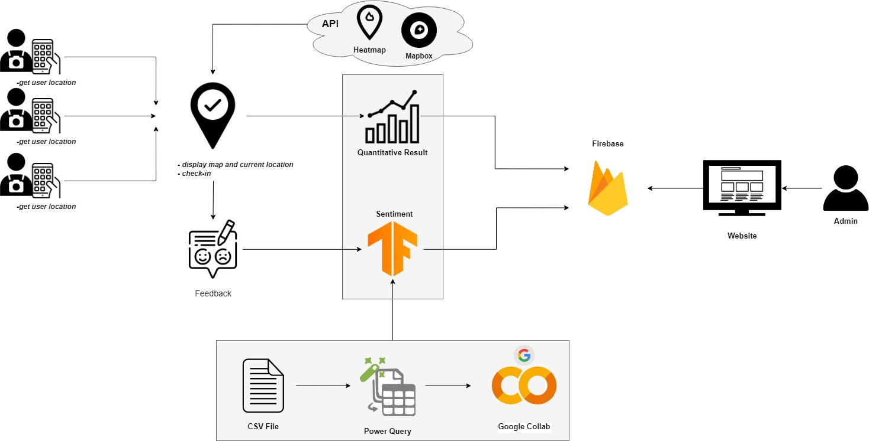

**Figure 1.** System Architecture of the Proposed System Figure 1 shows the system architecture of the system.

The system architecture of the proposed system explains the structure and represents the control relationship between the user and the system. It also illustrates the different outputs the system is capable of generating. The system would get the users' location using MapBox, after that the list of nearest tourist attraction would show already sorted from low to high in kilometers (km). Once the user found its nearest tourist attraction, they might click the check-in button and the users would add feedback afterwards. The said feedback would be encoded through the database, which is Firebase, along with Tourist Information, Tourist Attraction Information, and Sentiment Result.

*Database Design*

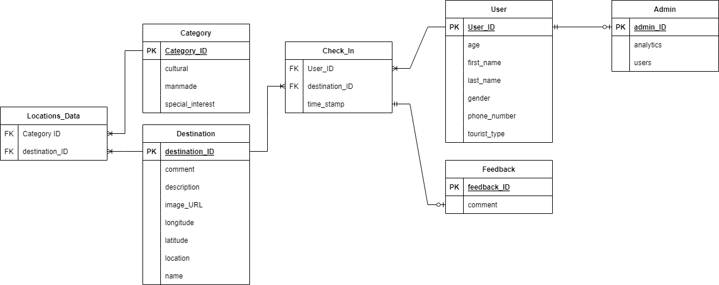

**Figure 2.** Database Design of the Proposed System Figure 2 shows the database design of the proposed system

which shows the relationship of the entity related and the attribute of the system to the tourism industry.

*Procedural and Object-Oriented Design*

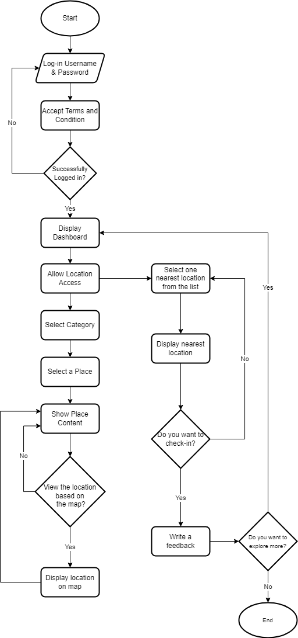

**Figure 3.** Procedural Design of the Proposed System (Mobile Component)

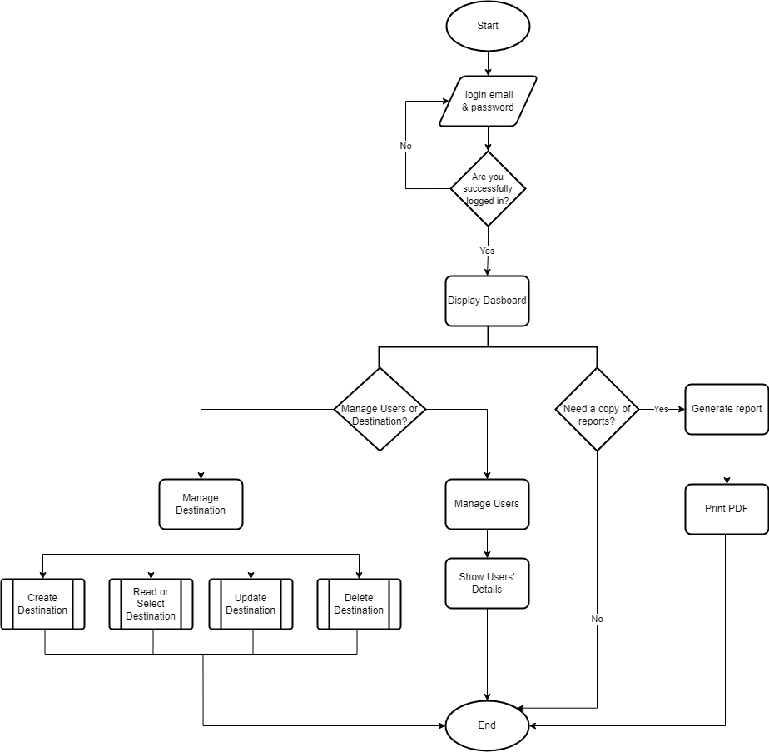

**Figure 4.** Procedural Design of the Proposed System (Web Component)

Figure 3 and Figure 4 illustrate the procedural design of Mobile and Web Components. The procedural design demonstrates the projected flow of a transaction in the

overall operations of the system.

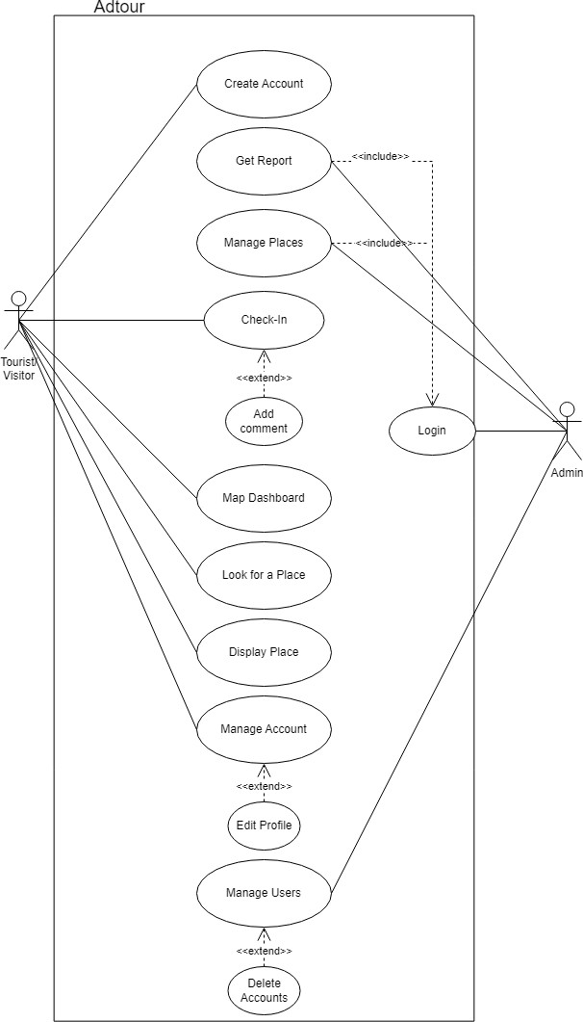

**Figure 5.** Object- oriented Design of the Proposed System

Figure 5 shows the possible functions for the development of the system.

Methodology

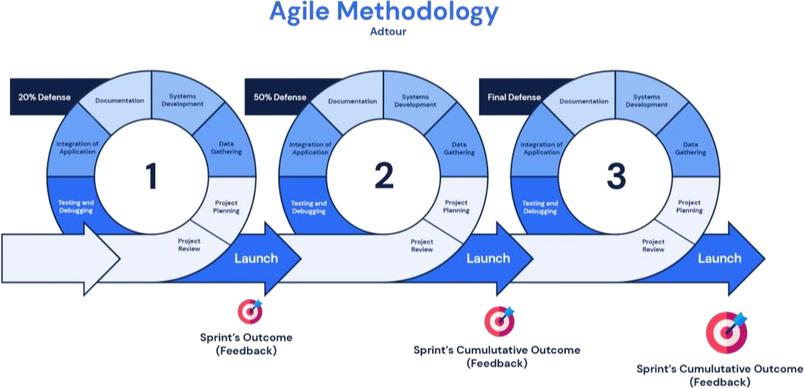

**Figure 6.** System Development Life Cycle of the Proposed System

Figure 6 shows the System Development Life Cycle of the Proposed System. The first stage is the project review stage. A project review is an assessment of the status of a project, at a particular point in time. During the project review, a decision is made as to whether or not the team has met the objectives and is approved to proceed to the next project phase.

The second stage is the project planning stage, it is when the researchers will address how to complete a project in a certain timeframe, usually with defined stages and designated resources.

The third stage is the data-gathering stage wherein the researchers gathered the information about the subject of the research and software and hardware components of the system. They also performed reviews to the gathered information the results of this stage were reviewed to secure correctness and veracity of the gathered information.

The fourth stage is the development of the system which involves database, graphical user interface and system architecture initiation, learning the programming language and coding.

The fifth stage is the software documentation, this provides information about a software program for everyone involved in its creation, deployment and use.

The sixth stage is the system integration or the integration of applications, where the process of assembling, configuring and connecting hardware components of the system to the software takes place.

The seventh stage is the testing and debugging proper software testing method will be used to determine bugs on the program and to ensure that the software is working properly according to its designated specification and design. The arrow indicates that if there is something wrong in the testing and debugging phase it goes back to the data gathering phase until the system is ready for the final presentation.

The last stage is the presentation and submission of the final output.

Statistical Treatment of Data

The data gathered from the users’ evaluation were subjected to appropriate descriptive statistics. Means were employed in this study.

The following are the scale of means and their respective descriptions.

*Means*

Composite weighted means was used to determine the

levels of the users’ evaluation of the proposed system.

The following are the scale of means and their respective descriptions:

Scale Description

|  |  |  |  |
| --- | --- | --- | --- |
| 5 | – | 4.1 | Very Good |
| 4 | – | 3.1 | Good |
| 3 | – | 2.1 | Fair |
| 2 | – | 1.1 | Poor |
|  | 1 |  | Very Poor |

CHAPTER 4 RESULTS AND DISCUSSION

Implementation

*Technical Specifications*

Certain requirements and specifications are necessary for the system to be employed and agreed upon. These specific requirements must be observed to avoid unnecessary effects that may be encountered. In the following sections, the software and hardware specifications are presented.

*Software Specifications*

The proposed system has certain software requirements that would ensure the systems accurate processing for it to work properly and employ the systems functionalities and to be in service. The software specifications describe the requirements of the developed system with relation to the software.

The system was developed using Visual Studio Code version 1.72.0 (user setup) with Dart version v3.50.0, Flutter v3.50.0. The VS Code is a source-code editor made by Microsoft with the Electron Framework, for Windows, Linux and

macOS. Features include support for debugging, syntax highlighting, intelligent code completion, snippets, code refactoring, and embedded Git. It helps the programmer write code, helps in debugging and corrects the code using the intelli-sense method. In normal terms, it facilitates users to write the code in an easy manner. Its features let the user modify the editor as per the usage, which means the user is able to download the libraries from the internet and integrate it with the code as per his requirements.

Dart is a programming language designed for client development, such as for the web and mobile apps. It is developed by Google and can also be used to build server and desktop applications. It is an object-oriented, class-based, garbage-collected language with C-style syntax.

Flutter is a free and open-source UI framework for creating native mobile applications from Google. Released in 2017, Flutter allows developers to build mobile applications with a single codebase and programming language. This capability makes building both iOS and Android apps simpler and faster.

The mobile application requires Internet connectivity to function including a permission for location access. The mobile app is compatible with Android devices running in Android 6 and above.

The system admin was developed using Simple React Snippets v1.2.7. The system can run on any updated browsers. React. js, more commonly known as React, is a free, open- source JavaScript library. It works best to build user interfaces by combining sections of code (components) into full websites. Originally built by Facebook, Meta and the open-source community now maintain it.

*Hardware Specifications*

In the hardware necessities, the researchers used and tested the mobile application with an Android 8.1.0 version of the operating system, an Octa-core processor, 3.00GB of RAM, and a 32.0 GB device storage. For system admin, the researchers tested the application on a desktop with Intel(R) Core (™) i5-3230M CPU @ 2.60GHz, 4GB RAM, and 64-bit operating system.

*User Specifications*

The users of this application are mostly tourists. Tourists are persons traveling to and staying outside their usual environment for not more than one consecutive year for leisure, business and other purposes. The mobile application could be very useful to tourists. It could help them locate whether they are in Iloilo City. Tourists may be easily informed of the nearest spots to visits using the application. The user must have the knowledge in using Android Phones. The system is user-friendly: therefore, the user has no difficulty in using the application.

*System Inputs and Outputs*

The tourist inputs data by providing their basic information. The information will show on their profile alongside with their username on the feedback section. After logging in, the user is taken to the explore screen where they may select the type of tourist attraction they want to visit (cultural, man-made, and special interest). After the user selects a category, a list of tourist attractions in Iloilo City that fall within that category is displayed. A

new screen with a description of the place and a picture of the tourist attraction will appear when they click the location.

When they visit a place, they will check-in on the application for immediate log-in. In this study, a system measures the feedback of a tourist using Sentiment Analysis, it requires the tourist to input the feedback about a tourist spot. Then the application displays the feedback whether it's positive or negative. The results of the tourists' feedback will be forwarded to the Iloilo City Tourism Office, who will assess the feedback of the city's attractions from tourists.

Figure 7 to 33 show the different input required and outputs generated from the system. These figures show the overall presentation of inputs and outputs of the system.

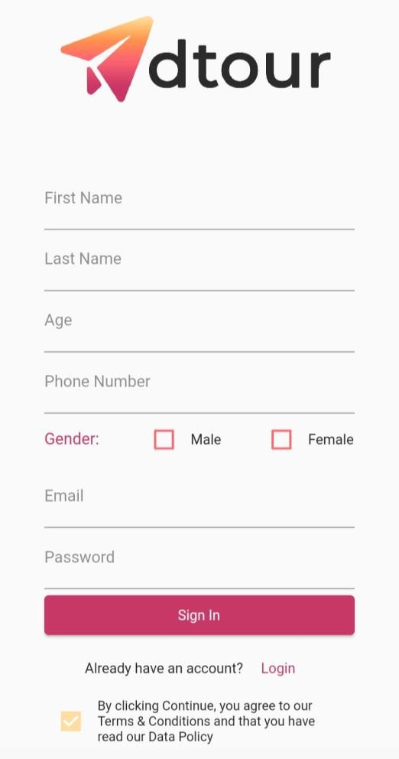

**Figure 7.** Sign-up Screen Interface

Figure 7 shows fill-out form details for users that will join the application. This will allow users to create an account by initially filling out the first name, last name, age, gender, email, and password. All these details will be directed to the application’s database- the Firebase database.

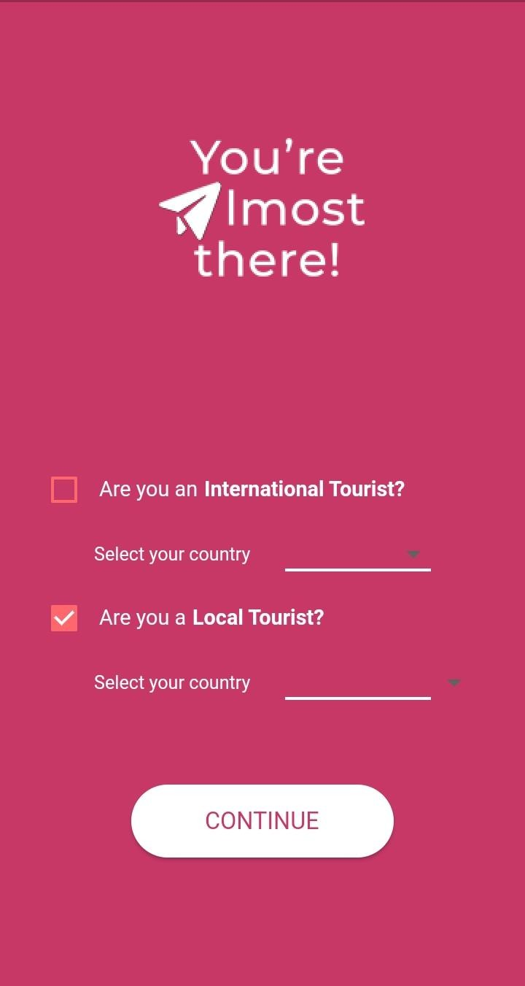

**Figure 8.** Register New User with International or Local Tourist Survey Form

Figure 8 displays a form which asks if the user is an international or local tourist.

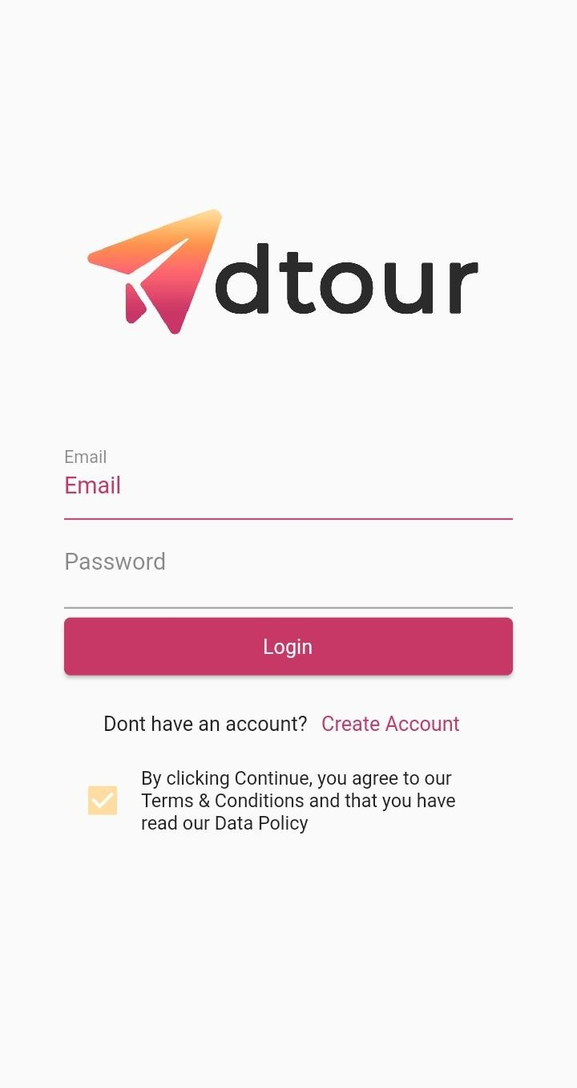

**Figure 9.** Login Screen Interface

Figure 9 shows the sign-in screen of the mobile application. In this form, the user is required to fill up necessary details by providing a previously agreed-upon username and password in order to gain access.

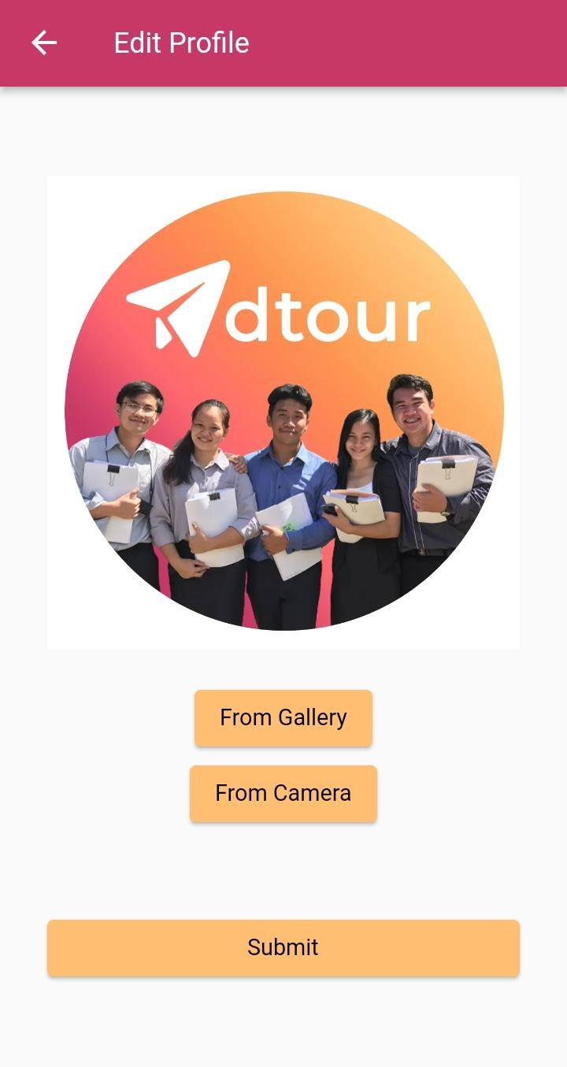

**Figure 10.** Profile Interface

Figure 10 shows the profile interface of the mobile application wherein the user can choose to submit a photo from the gallery or the camera.

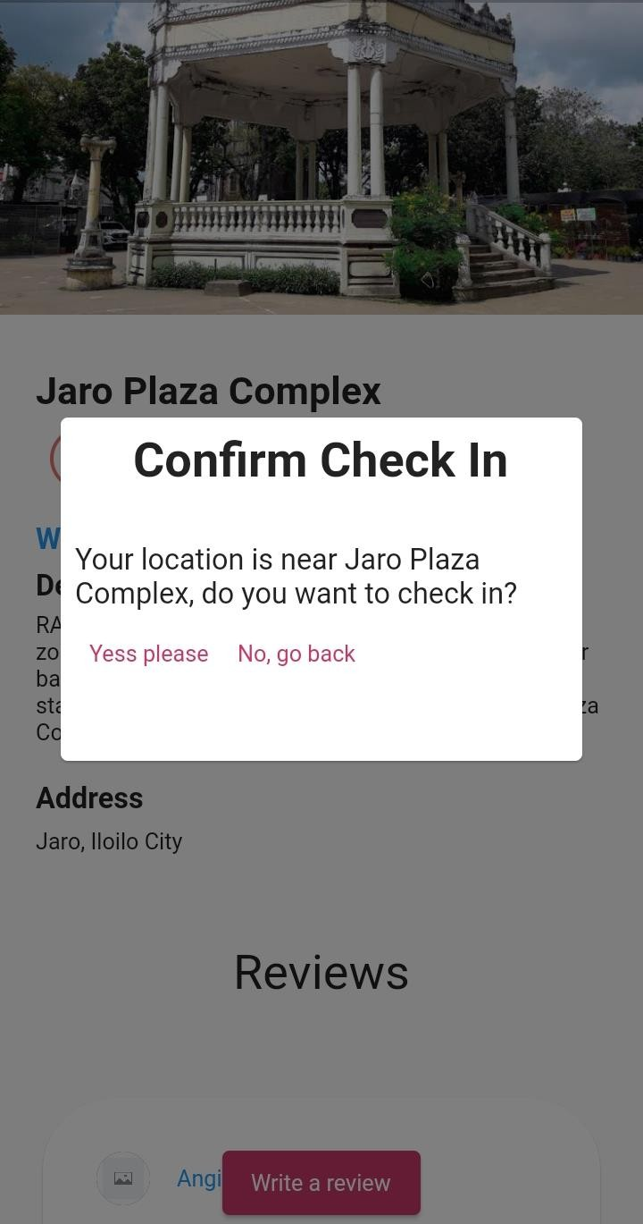

**Figure 11.** Automatic Check-in Confirmation Notification Figure 11 depicts the mobile app's check-in

notification. This notification will appear if the user's location is close to a tourist attraction. The pop-up dialog will ask the user to either check-in; or return to the home interface.

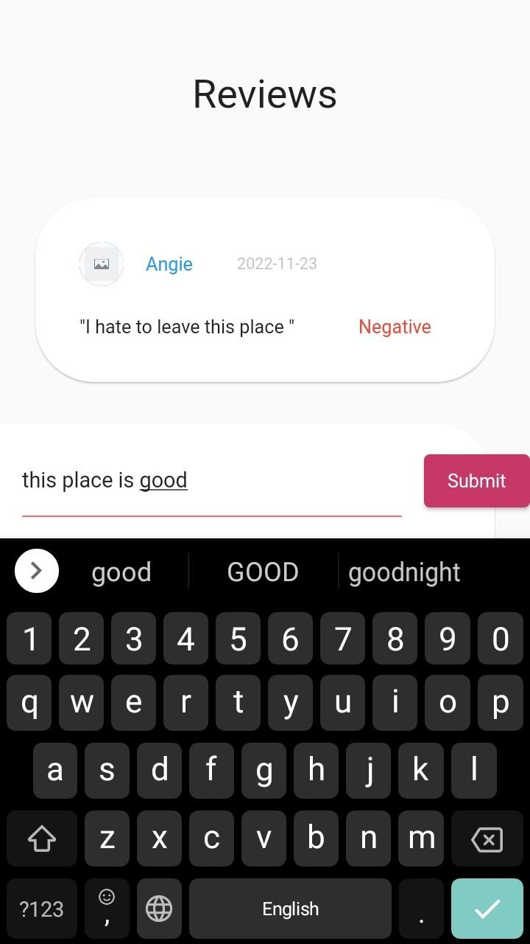

**Figure 12.** Crowdsourced Survey Form

Figure 12 illustrates the interface for the crowdsourced survey form. The user can only give feedback if a previous check-in status at that tourist attraction exists.

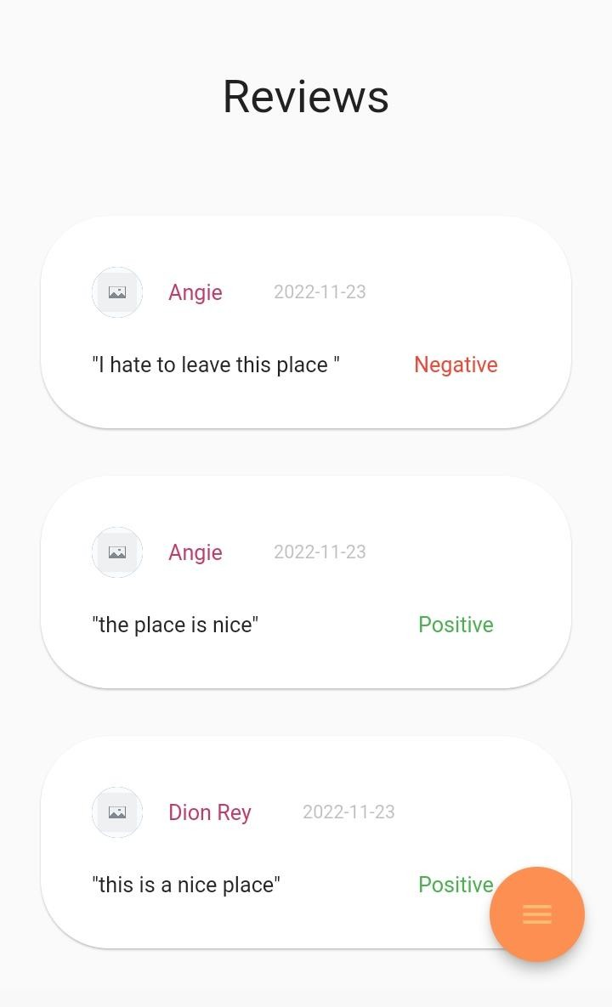

**Figure 13.** Quick Review of Crowdsourced Information with Sentiment Analysis

Figure 13 depicts the comments interface, where the user can view the comments as well as those of other users.

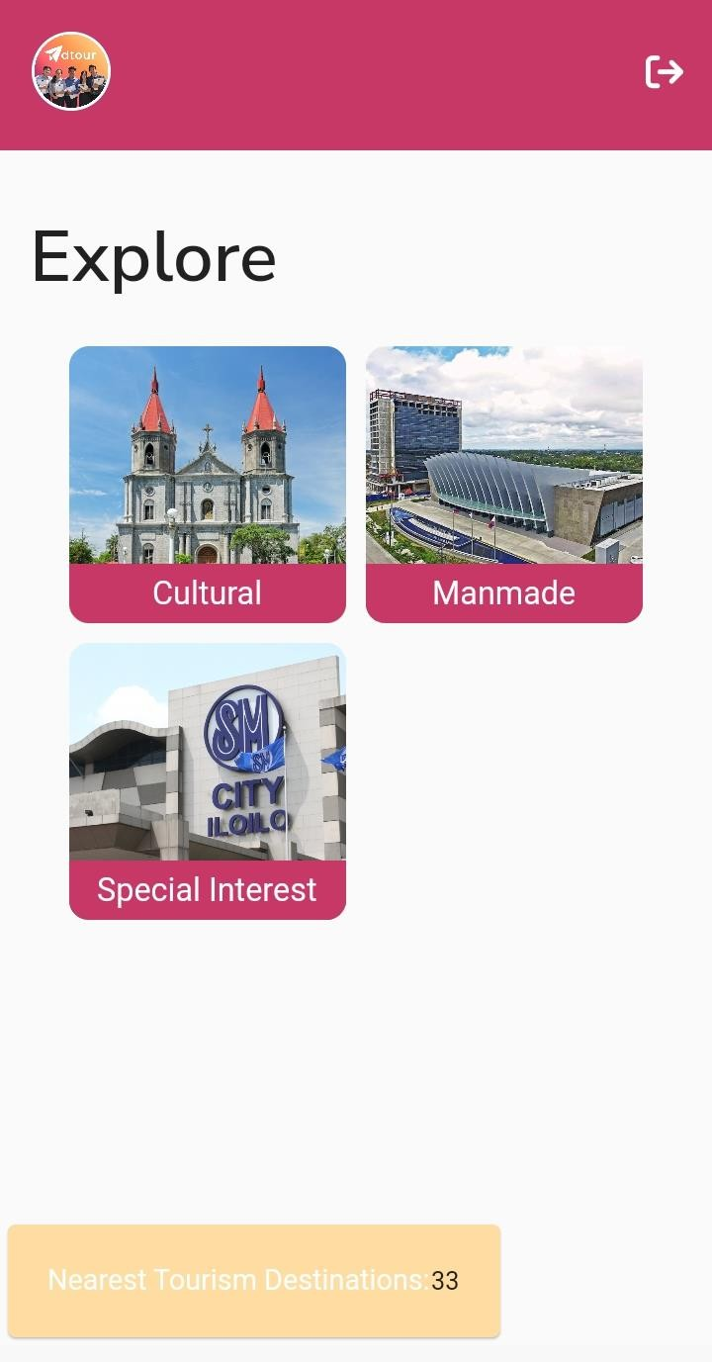

**Figure 14.** Mobile Interface of Adtour

Figure 14 depicts Adtour's Mobile Interface. On this page, the user can view the three categories of the tourist attractions which are Man-made, Cultural, and Special Interest. This page also displays the mobile application's check-notification.

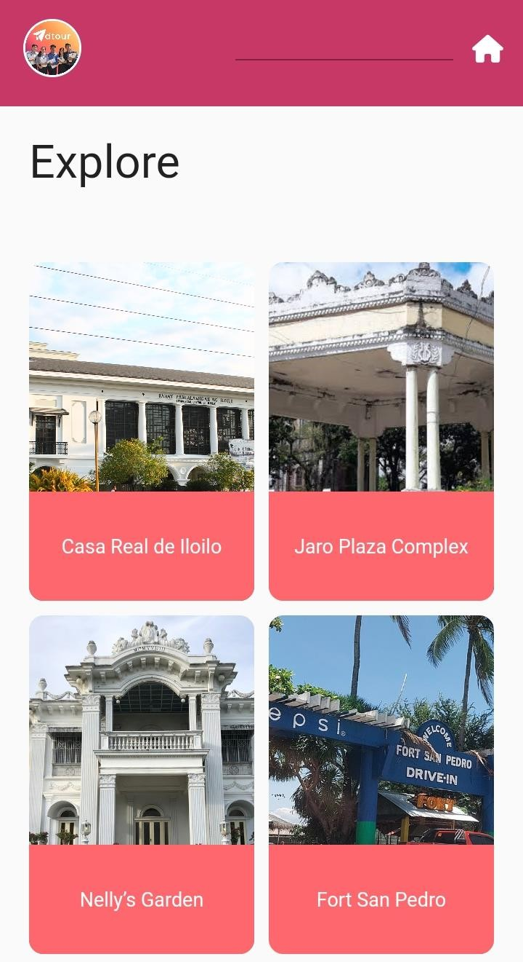

**Figure 15.** Mobile Interface for Cultural Page

Figure 15 shows the Mobile Interface of the Cultural Page, which includes the various tourist attractions classified as Cultural.

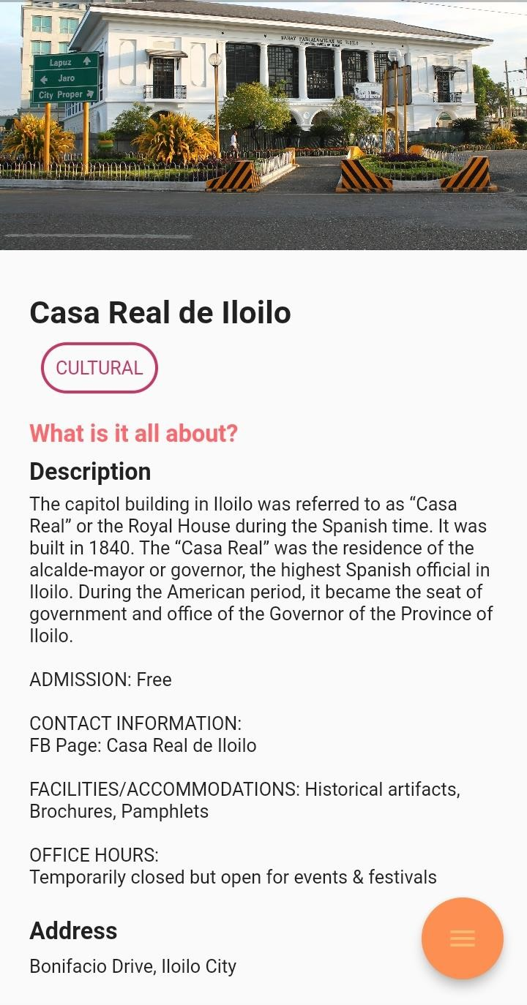

**Figure 16.** Mobile Interface for a Tourist Attraction from Cultural Page

Figure 16 depicts the Mobile Interface for a Tourist Attraction from a Cultural Page, which includes a photo, description, and address of the tourist attraction. This page also includes a review of tourist attraction and a map feature.

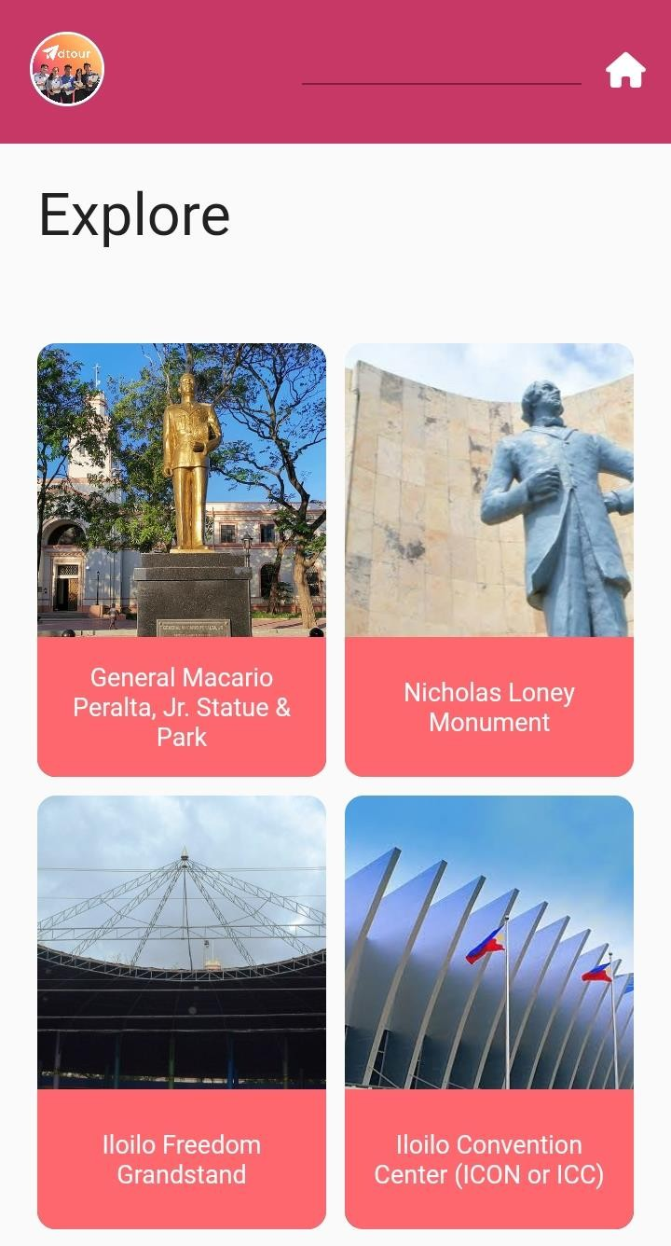

**Figure 17.** Mobile Interface for Man-Made Page

Figure 17 shows the Mobile Interface of the Man-Made Page, which includes the various tourist attractions classified as Man-Made.

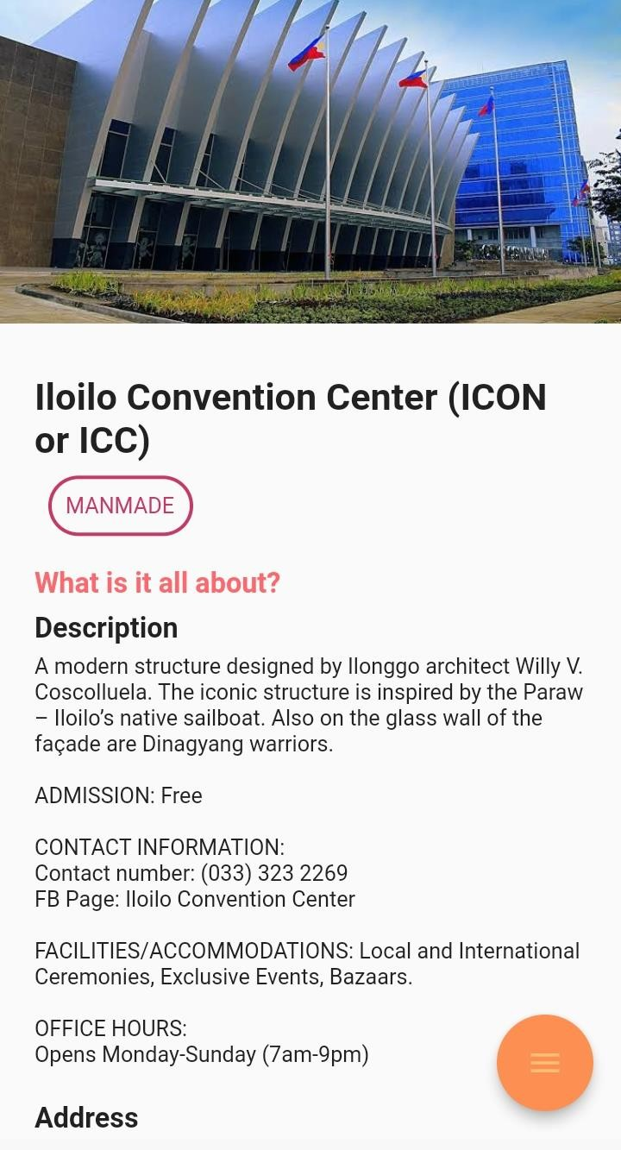

**Figure 18.** Mobile Interface for a Tourist Attraction from

Man-Made Page

Figure 18 depicts the Mobile Interface for a Tourist Attraction from a Man-Made Page, which includes a photo, description, and address of the tourist attraction. This page also includes a review of tourist attraction and a map feature.

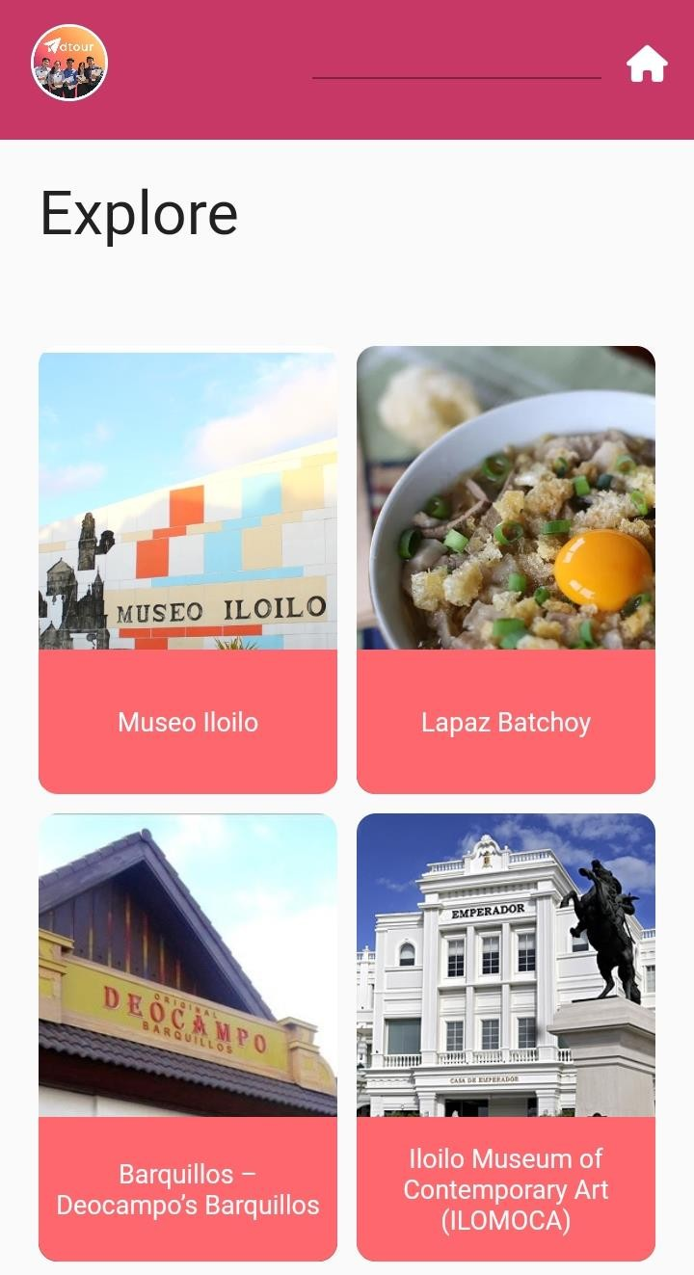

**Figure 19.** Mobile Interface for Special Interest Page Figure 19 shows the Mobile Interface of the Special

Interest Page, which includes the various tourist attractions classified as Special Interest.

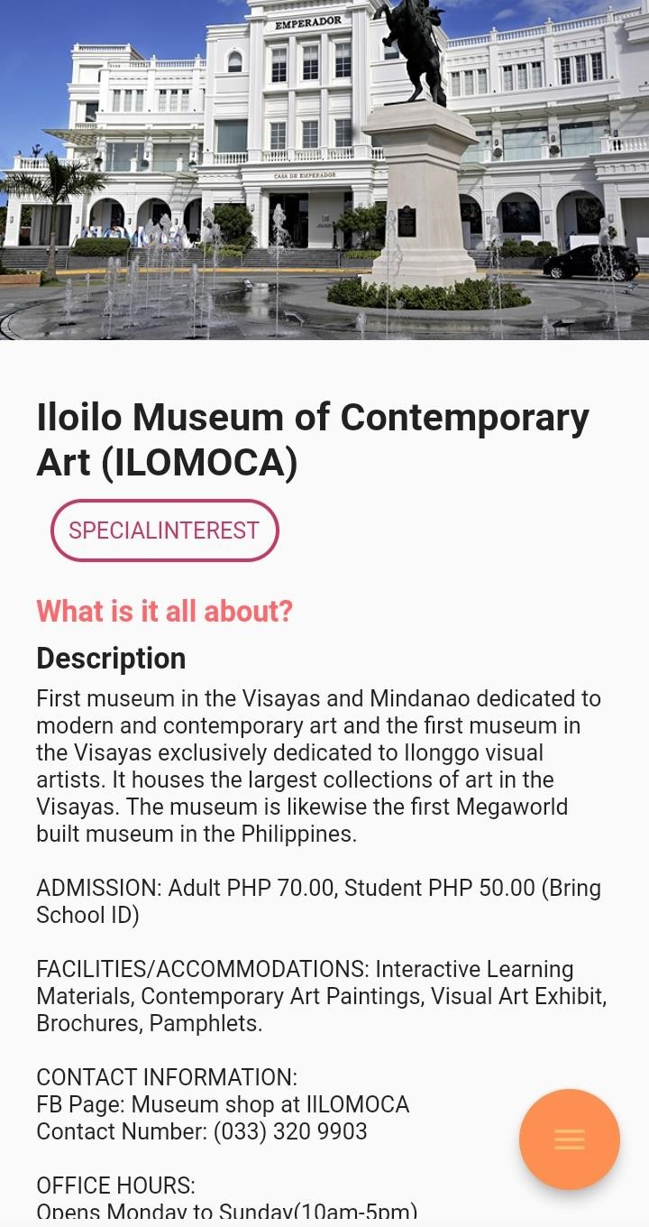

**Figure 20.** Mobile Interface for a Tourist Attraction from Special Interest Page

Figure 18 depicts the Mobile Interface for a Tourist Attraction from a Special-Interest Page, which includes a photo, description, and address of the tourist attraction. This page also includes a view of tourist attraction and a

map feature.

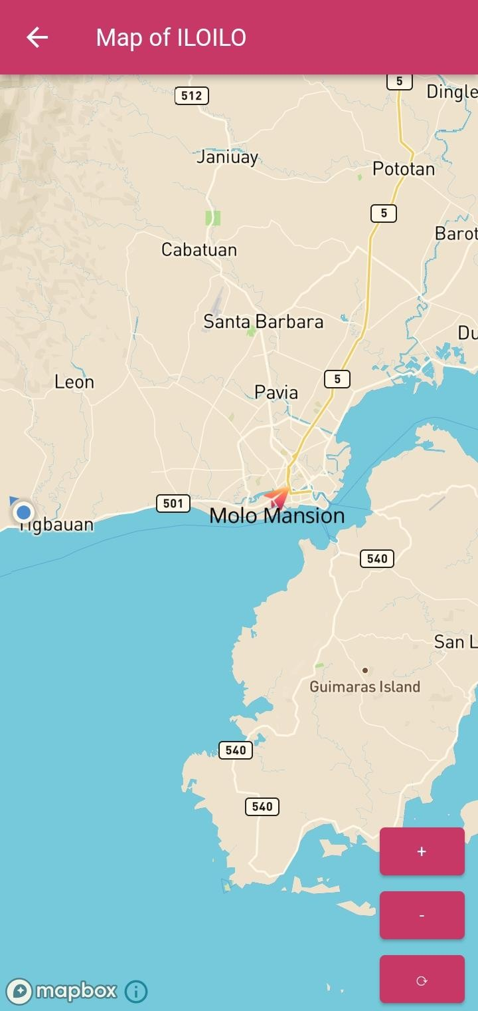

**Figure 21.** Map Interface

Figure 21 depicts the Map Interface of the Mobile Application using Mapbox. The map allows the user to scroll around by holding one finger down on the screen and moving it in any

direction, adjust the pitch by holding two fingers down on

the screen and moving them vertically across the screen, gradually zoom in/out by pinching with two fingers to adjust the zoom level moving the fingers apart to zoom in, move fingers closer together to zoom out, and rotate by holding two fingers down on the screen and moving them in a circular motion to rotate the map (adjust the bearing).

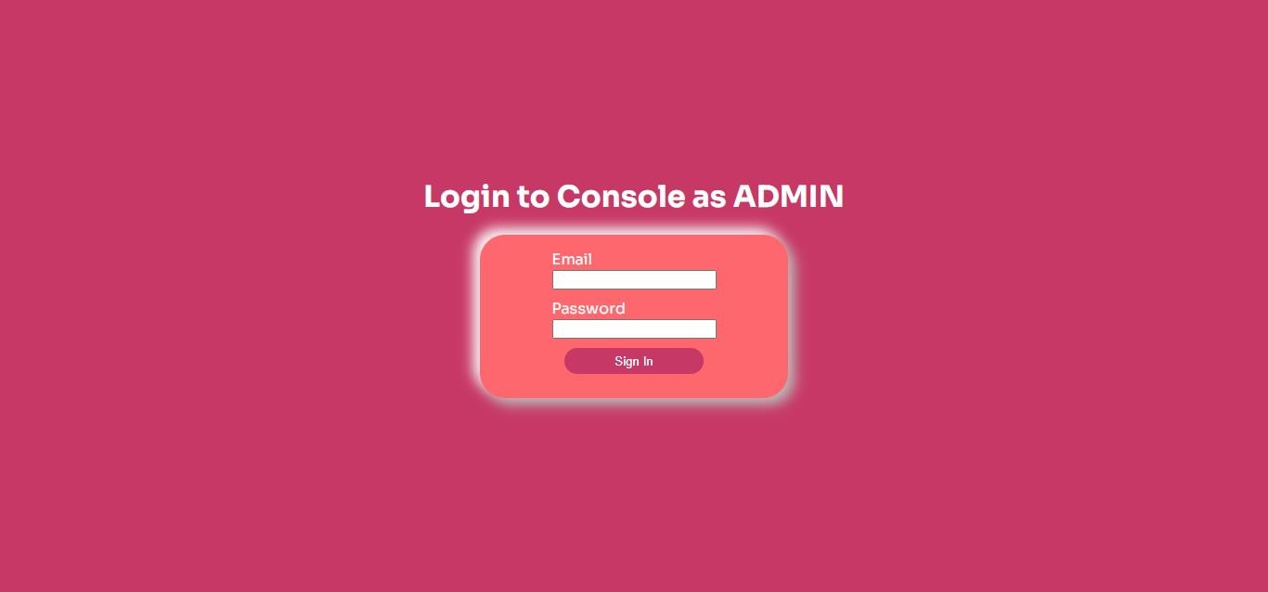

**Figure 22.** Admin Authentication

Figure 22 depicts the admin server's sign-in screen. In order to gain access, the admin must fill out this form with the necessary information, including a previously agreed-upon username and password.

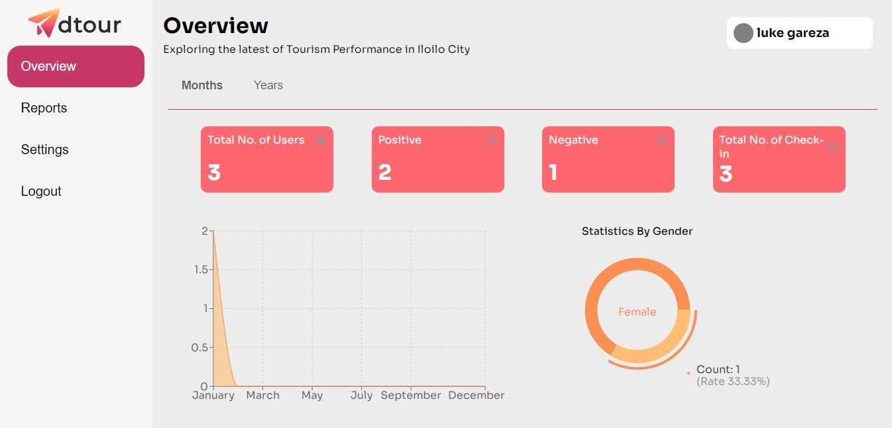

**Figure 23.** Web Interface for Overview Page

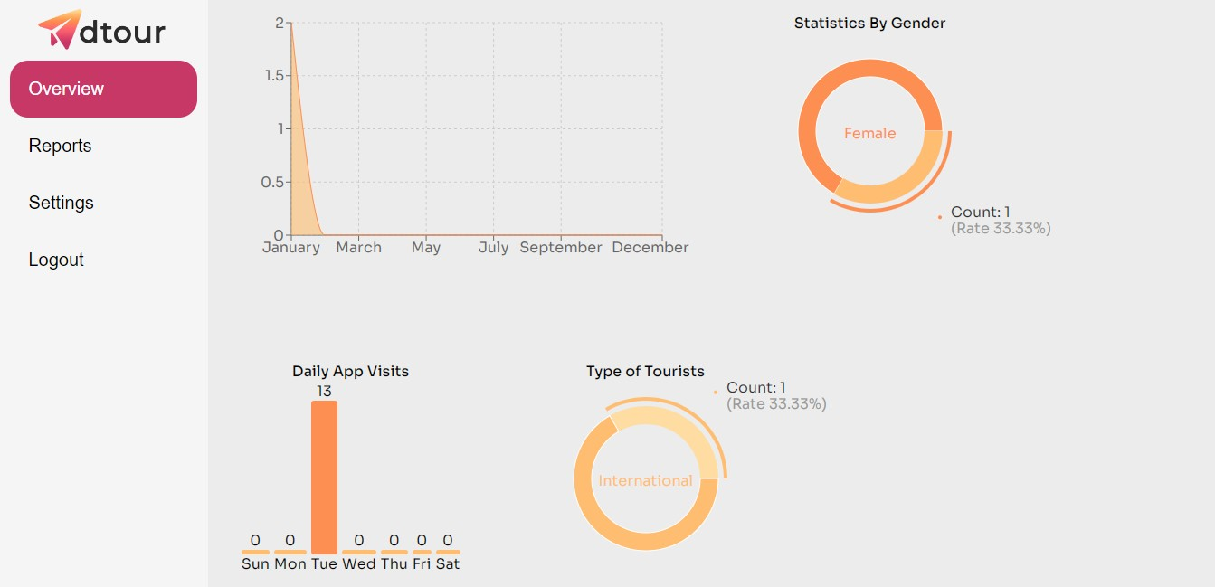

**Figure 24.** Web Interface for Overview Page (cont.)

Figures 23 and 24 shows the Web Application's Overview Page. The overview page displays real-time analytics, such as the total number of users, total number of check-ins, total

number of positive and negative feedbacks, daily app visits, statistics by gender, statistics by tourist type, and specific feedback for each tourist attraction.

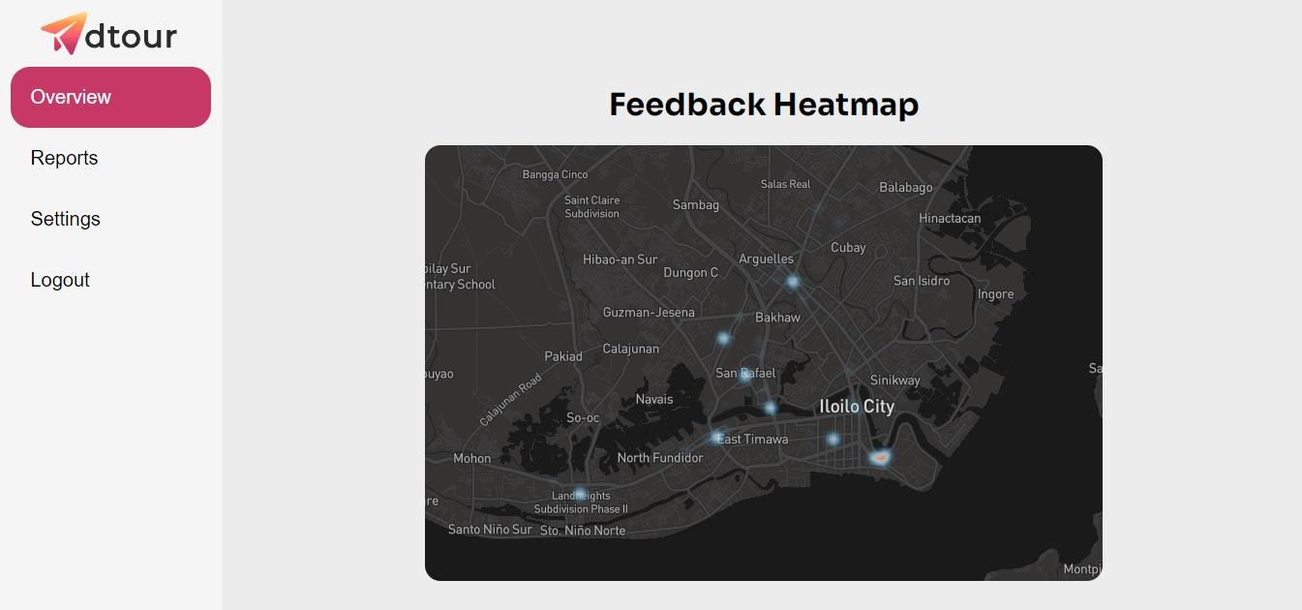

**Figure 25.** Feedback Heatmap

Figure 25 shows the heat map that displays the number of feedback to be classified along with its respective colors such as positive (blue) and negative (red).

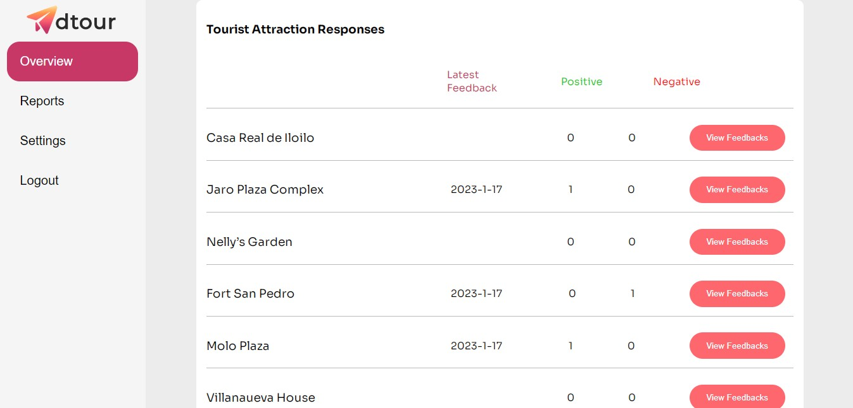

# Figure 26. Summary of Feedbacks

Figure 26 shows a glimpse of the total number of feedback real-time.

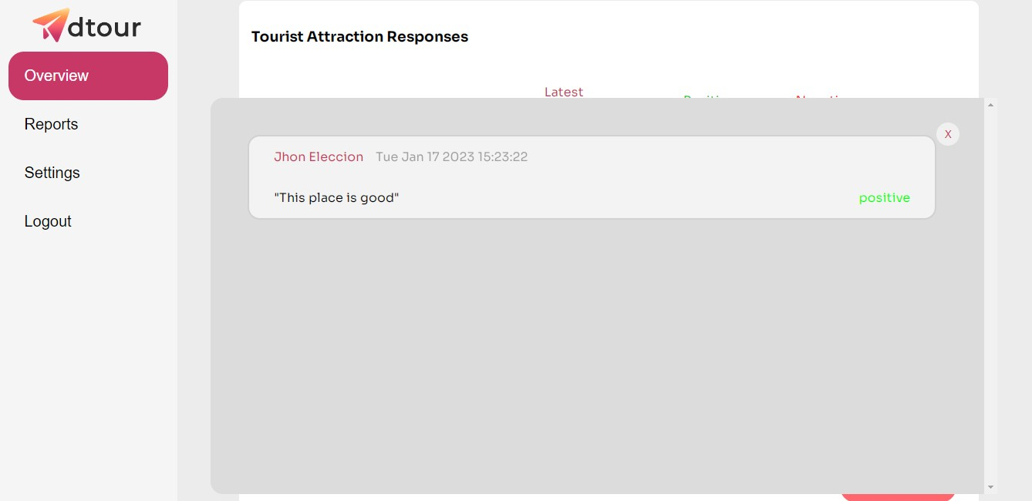

**Figure 27.** Feedback

Figure 27 shows the feedback in the web application from the mobile application.

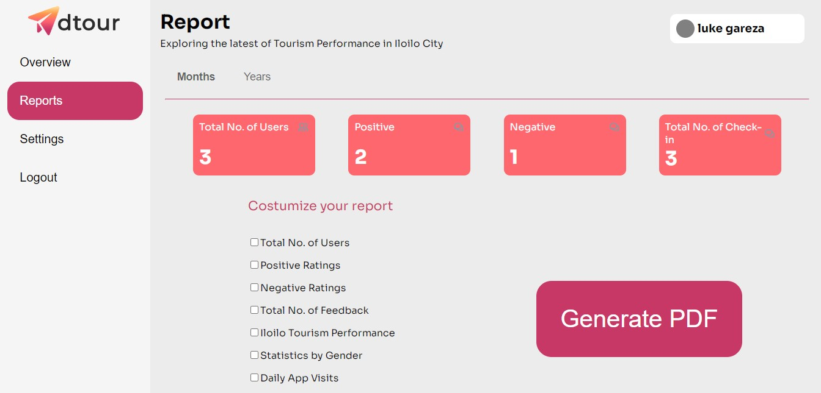

**Figure 28.** Web Interface for Reports Page

Figure 28 depicts the Reports Page of Web Application. This is the page where the admin can customize the reports based on the real-time analytics.

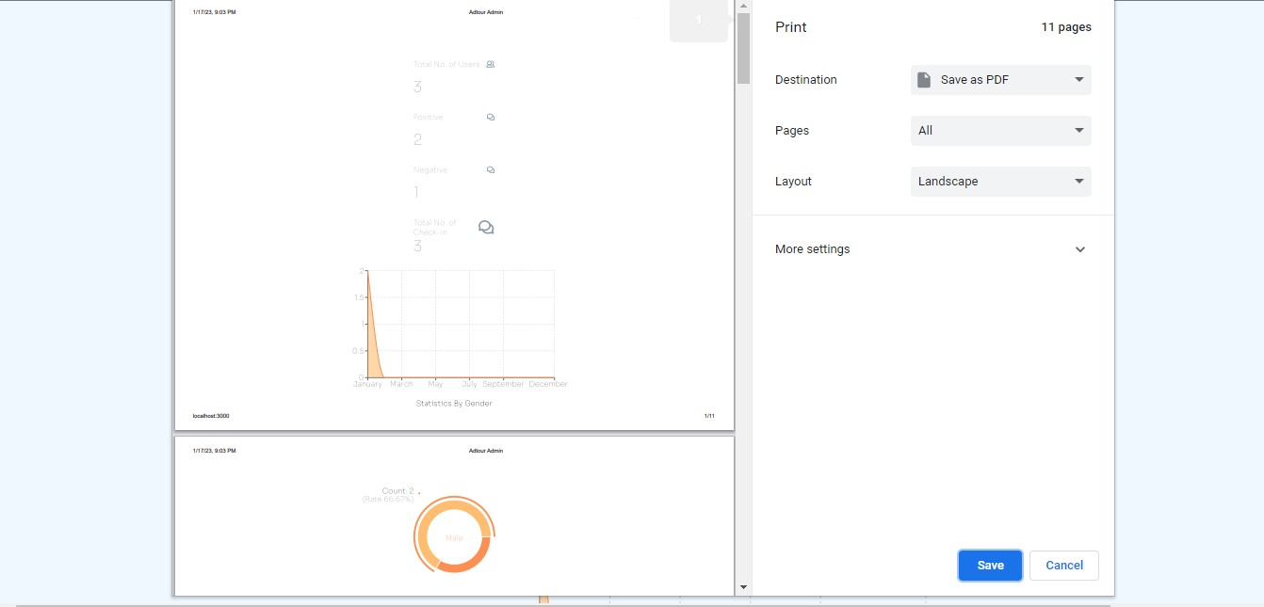

**Figure 29.** Generating Reports into PDF from Reports Page

Figure 29 shows an example of generating customized reports in PDF format.

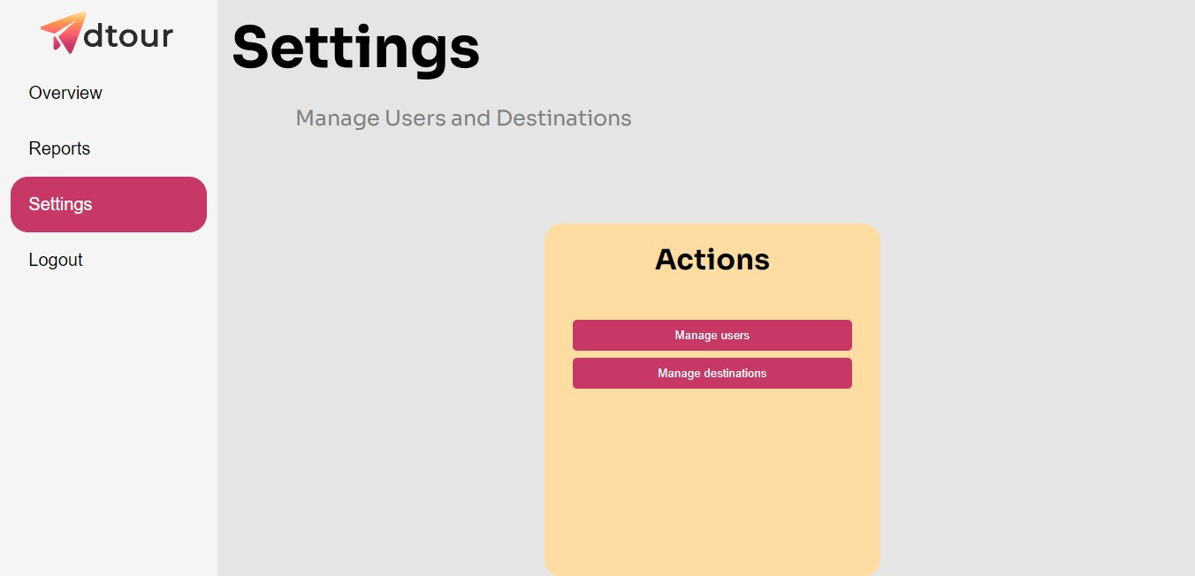

**Figure 30.** Web Interface of Settings Page

Figure 30 depicts the web interface of the settings page. The admin can manage a user and a destination from this page.

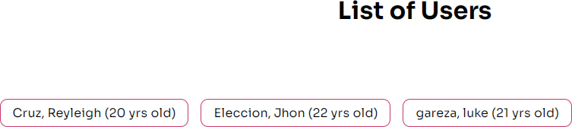

**Figure 31.** Manage Users

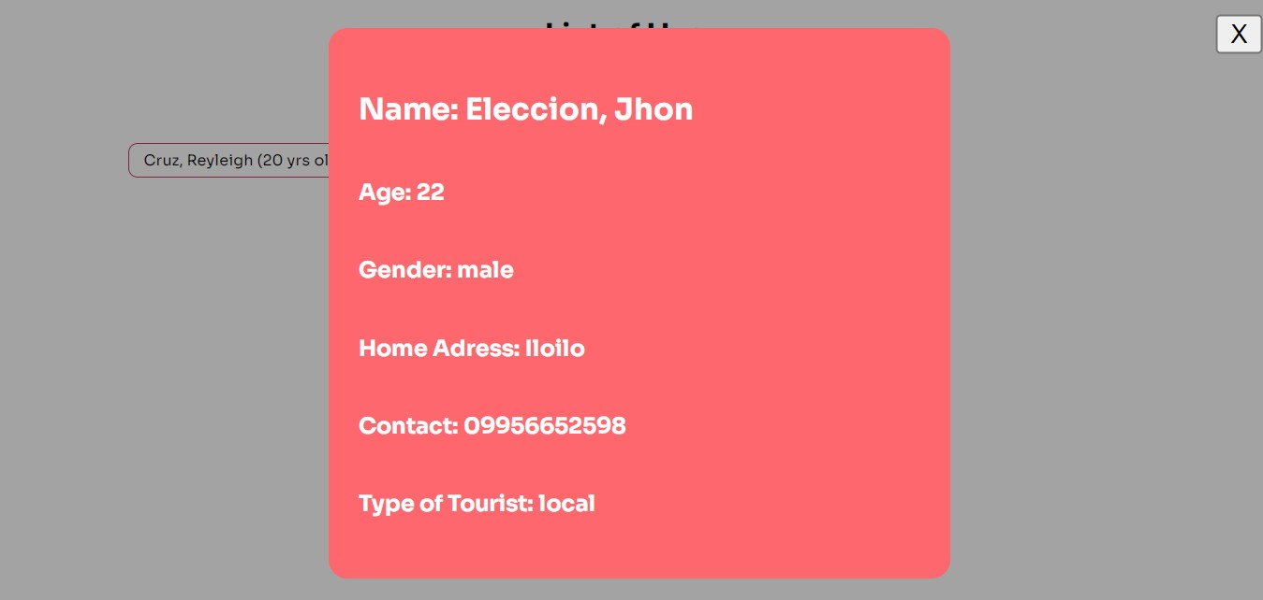

**Figure 32.** Manage Users (cont.)

Figure 31 and 32 depicts the managed user interface. The admin can view the list of users with user information such as name, address, age, gender, contact, and tourist type.

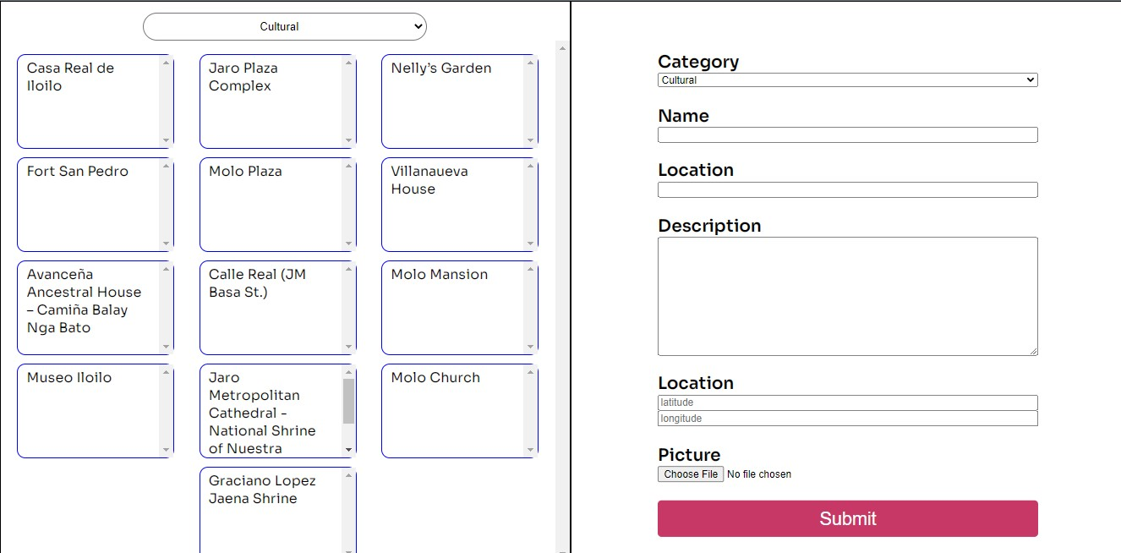

**Figure 33.** Manage Tourist Attractions

Figure 33 shows the web application's managed destinations interface. The admin can use this interface to add, delete, and update tourist destinations.

System Evaluation Results

The system was presented to the users of the mobile application to determine the quality of the proposed system. The criteria were divided into following parts:

1. Functional Stability- for completeness, correctness, and appropriateness;
2. Reliability- for maturity, availability, fault tolerance, and recoverability;
3. Portability- for adaptability, durability, installability, and affordability;
4. Usability- for appropriateness recognizability, learnability, operability, user-error protection, user- interface aesthetics, and accessibility;
5. Performance efficiency- for time-behavior, resource- utilization, and capacity;
6. Security- for confidentiality, integrity, non- repudiation, accountability, and authenticity;
7. Compatibility- for co-existence and interoperability;
8. Maintainability- for modularity, reusability, analyzability, modifiability, and testability.

**Table 1**

ISO 25010- Functional Stability

|  |  |  |  |  |  |  |  |
| --- | --- | --- | --- | --- | --- | --- | --- |
| **Indicators** | | **VG** | **G** | **F** | **P** | **VP** | **Mean** |
| Completeness | The set of instructions all the specified task  and user objectives. | 6 | 0 | 0 | 0 | 0 | 5.00 |
| Correctness | The system provides correct results with the needed degree of precision. | 2 | 4 | 0 | 0 | 0 | 4.33 |
| Appropriateness | The system provides the accomplishment of specified tasks and objectives. | 1 | 5 | 0 | 0 | 0 | 4.17 |

***Functional Stability.*** The results as shown in Table 1

concluded that the mobile application has “Very Good”

functional stability based on its overall mean value of 4.5.

“Very Good” completeness with 5.00 mean, “Very Good” correctness with 4.33, and “Very Good” appropriateness with mean value of 4.17. Results indicate that the application is capable of offering functions that meet the implied needs.

**Table 2**

ISO 25010- Reliability

|  |  |  |  |  |  |  |  |
| --- | --- | --- | --- | --- | --- | --- | --- |
| **Indicators** | | **VG** | **G** | **F** | **P** | **VP** | **Mean** |
| Maturity | A system, product or component meets for reliability under normal operation. | 3 | 3 | 0 | 0 | 0 | 4.50 |
| Availability | A product or system is operational and accessible when required for use | 3 | 3 | 0 | 0 | 0 | 4.50 |
| Fault tolerance | A system, product, or component | 1 | 5 | 0 | 0 | 0 | 4.17 |

|  |  |  |  |  |  |  |  |
| --- | --- | --- | --- | --- | --- | --- | --- |
|  | operates as intended despite the presence of hardware or software results. |  |  |  |  |  |  |
| Recoverability | In the event of an interruption or a failure, a product or system can recover the data and establish the desired state of the system. | 2 | 4 | 0 | 0 | 0 | 4.33 |

***Reliability.*** The results shown in Table 2 revealed that the mobile application has “Very Good” reliability based on its overall mean value of 4.38. “Very Good” maturity with 4.50 mean, “Very Good” availability with 4.50 mean, “Very Good” fault tolerance with 4.17 mean, and “Very Good” recoverability with 4.33 mean. This indicates that it meets

the reliability indicators and the quality of performing consistently well.

**Table 3**

ISO 25010- Portability

|  |  |  |  |  |  |  |  |
| --- | --- | --- | --- | --- | --- | --- | --- |
| **Indicators** | | **VG** | **G** | **F** | **P** | **VP** | **Mean** |
| Adaptability | A product or system can effectively and efficiently be adapted for different or evolving hardware, software or other operational or usage environments. | 1 | 3 | 2 | 0 | 0 | 3.83 |
| Durability | A product or system can withstand technology evolution | 0 | 6 | 0 | 0 | 0 | 4.00 |

|  |  |  |  |  |  |  |  |
| --- | --- | --- | --- | --- | --- | --- | --- |
|  | and changes without costly redesign, reconfiguration or recording. |  |  |  |  |  |  |
| Installability | A product or system can be successfully installed and/or uninstalled in a specified environment. | 6 | 0 | 0 | 0 | 0 | 5.00 |
| Replaceability | A product can replace another specified software product for the same purpose in the same environment. | 0 | 5 | 1 | 0 | 0 | 3.83 |
| Affordability | A product or system can increase efficiency and | 0 | 5 | 1 | 0 | 0 | 3.83 |

|  |  |  |  |  |  |  |  |
| --- | --- | --- | --- | --- | --- | --- | --- |
|  | productivity by reducing the time and costs involved in delivering instruction |  |  |  |  |  |  |

***Portability.*** The above table illustrates the result that the mobile application has an overall portability mean of 4.09. “Good” adaptability with 3.83 mean, “Good” durability with

4.00 mean, “Very Good” installability with 5.00 mean, “Good” replaceability with 3.83 mean, and “Good” affordability with

3.83 mean value. This means that the application is capable of being transferred from one environment to another.

**Table 4**

ISO 25010- Usability

|  |  |  |  |  |  |  |  |
| --- | --- | --- | --- | --- | --- | --- | --- |
| **Indicators** | | **VG** | **G** | **F** | **P** | **VP** | **Mean** |
| Appropriateness recognizability | Users can recognize whether a product or the system is appropriate for their needs | 3 | 3 | 0 | 0 | 0 | 4.50 |
| Learnability | A product or the system enables the user to learn how to use it with effectiveness, efficiency in emergency situations. | 2 | 4 | 0 | 0 | 0 | 4.33 |
| Operability | A product or system easy to operate, | 6 | 0 | 0 | 0 | 0 | 5.00 |

|  |  |  |  |  |  |  |  |
| --- | --- | --- | --- | --- | --- | --- | --- |
|  | control and appropriate to use. |  |  |  |  |  |  |
| User error protection | A product or system protects users against making errors. | 1 | 5 | 0 | 0 | 0 | 4.17 |
| User interface aesthetics | A user interface enables pleasing and satisfying interactions for the user. | 1 | 5 | 0 | 0 | 0 | 4.17 |
| Accessibility | A product or system can be used by people with the widest range of characteristics and capabilities to achieve a specified | 3 | 3 | 0 | 0 | 0 | 4.50 |

|  |  |  |  |  |  |  |  |
| --- | --- | --- | --- | --- | --- | --- | --- |
|  | goal in a specified context of use. |  |  |  |  |  |  |

***Usability.*** The results shown in Table 4 displays that the system has “Very Good” usability based on its overall mean of value of 4.44. “Very Good” appropriateness recognizability with 4.50 mean, “Very Good” learnability with 4.33 mean, “Very Good” operability with 5.00 mean, “Very Good” user error protection with 4.17 mean, “Very Good” user interaction aesthetics with 4.17 mean, and “Very Good” accessibility with

4.50 mean. This means that the system achieved a defined goal effectively, efficiently, and satisfactorily.

**Table 5**

ISO 25010- Performance Efficiency

|  |  |  |  |  |  |  |  |
| --- | --- | --- | --- | --- | --- | --- | --- |
| **Indicators** | | **VG** | **G** | **F** | **P** | **VP** | **Mean** |
| Time-behavior | The response and processing time and throughput rates of a product or system when performing its functions, meet requirements. | 5 | 1 | 0 | 0 | 0 | 4.83 |
| Resource utilization | The amounts and types of resources used by a product or system, when performing its functions meet requirements. | 0 | 6 | 0 | 0 | 0 | 4.00 |

|  |  |  |  |  |  |  |  |
| --- | --- | --- | --- | --- | --- | --- | --- |
| Capacity | The maximum limits of the product or system parameters meet requirements. | 3 | 3 | 0 | 0 | 0 | 4.50 |

***Performance Efficiency.*** Results above have accumulated with an overall performance efficiency mean of 4.44. “Very Good” time behavior of 4.83, “Good” resource utilization of 4.00, and capacity mean of 4.50. This means that the mobile application has satisfied the required performance related to the number of resources used.

**Table 6**

ISO 25010- Security

|  |  |  |  |  |  |  |  |
| --- | --- | --- | --- | --- | --- | --- | --- |
| **Indicators** | | **VG** | **G** | **F** | **P** | **VP** | **Mean** |
| Confidentiality | The prototype ensures that data are accessible only to those authorized to have access. | 0 | 5 | 1 | 0 | 0 | 3.83 |
| Integrity | A system, product, or component prevents unauthorized access to, or modification of, computer programs or data. | 0 | 6 | 0 | 0 | 0 | 4.00 |
| Non-repudiation | Actions or events can be proven to have taken place so | 1 | 4 | 1 | 0 | 0 | 4.00 |

|  |  |  |  |  |  |  |  |
| --- | --- | --- | --- | --- | --- | --- | --- |
|  | that the events or actions cannot be repudiated later. |  |  |  |  |  |  |
| Accountability | The actions of an entity can be traced uniquely to the entity. | 1 | 4 | 0 | 0 | 0 | 4.00 |
| Authenticity | The identity of a subject or resources can be proved to be the one claimed. | 1 | 4 | 1 | 0 | 0 | 4.17 |

***Security.*** Table 6 has an overall mean security value of 4.00 categorized as “Good”. “Good” confidentiality with 3.83 mean, “Good” integrity with 4.00 mean, “Good” non repudiation with 4.00 mean, “Very Good” accountability with 4.17 mean, and "Good” authenticity with 4.00 mean. This generally means that the mobile application is somehow able to protect information and data from security vulnerabilities.

**Table 7**

ISO 25010- Compatibility

|  |  |  |  |  |  |  |  |
| --- | --- | --- | --- | --- | --- | --- | --- |
| **Indicators** | | **VG** | **G** | **F** | **P** | **VP** | **Mean** |
| Co-existence | A product can perform its required functions efficiently while sharing a common environment and resources with other products, without detrimental impact on any other product. | 5 | 1 | 0 | 0 | 0 | 4.83 |
| Interoperability | The two or more systems, products or components can exchange | 1 | 5 | 0 | 0 | 0 | 4.17 |

|  |  |  |  |  |  |  |  |
| --- | --- | --- | --- | --- | --- | --- | --- |
|  | information and use the information that has been exchanged. |  |  |  |  |  |  |

***Compatibility.*** The results shown in Table 7 revealed that the system has “Very Good” compatibility based on its overall mean value of 4.50. “Very Good” co-existence with 4.83 mean and “Very Good” interoperability with 4.17 mean. This means that the system or component can share data with other goods, systems, or components and/or execute its needed functions while sharing the same hardware or software environment.

**Table 8**

ISO 25010- Maintainability

|  |  |  |  |  |  |  |  |
| --- | --- | --- | --- | --- | --- | --- | --- |
| **Indicators** | | **VG** | **G** | **F** | **P** | **VP** | **Mean** |
| Modularity | The application is composed of discrete components such that a change to one component has minimal impact on other components. | 2 | 4 | 0 | 0 | 0 | 4.33 |
| Reusability | An asset can be used in more than ne system, or in building other assets. | 1 | 4 | 3 | 0 | 0 | 4.00 |
| Analyzability | It is possible to assess the impact on a product or system | 0 | 6 | 0 | 0 | 0 | 4.00 |

|  |  |  |  |  |  |  |  |
| --- | --- | --- | --- | --- | --- | --- | --- |
|  | of an intended change to one or more of its parts, or to diagnose a product for deficiencies or causes of failures, or to identify parts to be modified. |  |  |  |  |  |  |
| Modifiability | The application can be effectively and efficiently modified without introducing defects or degrading existing product quality. | 0 | 1 | 5 | 0 | 0 | 3.83 |
| Testability | Test criteria can be established for an application, product | 1 | 5 | 0 | 0 | 0 | 4.17 |

|  |  |  |  |  |  |  |  |
| --- | --- | --- | --- | --- | --- | --- | --- |
|  | or component and tests can be performed to determine whether those criteria have been met. |  |  |  |  |  |  |

***Maintainability.*** The results shown in Table 8 revealed that the system has “Good” maintainability based on its overall mean value of 4.07. “Very Good” modularity with 4.33 mean, “Good” reusability with 4.00 mean, “Good” analyzability with 4.00 mean, “Good” modifiability with 3.83 mean, and “Very Good” testability with 4.17 mean. This signifies that the system has attained the level of effectiveness and efficiency at which a product or system may be adjusted to improve, rectify, or adapt to changes in the environment and needs.

**Table 9**

Summary of ISO 25010

|  |  |  |
| --- | --- | --- |
| **Criteria** | **Overall Mean** | **Description** |
| Functional Stability | 4.50 | Very Good |
| Reliability | 4.38 | Very Good |
| Portability | 4.09 | Good |
| Usability | 4.44 | Very Good |
| Performance Efficiency | 4.44 | Very Good |
| Security | 4.00 | Good |
| Compatibility | 4.50 | Very Good |
| Maintainability | 4.07 | Good |
| **Grand Mean** | **4.30** | **Very Good** |

Legend:

Scale Description

|  |  |  |  |
| --- | --- | --- | --- |
| 5 | – | 4.1 | Very Good |
| 4 | – | 3.1 | Good |
| 3 | – | 2.1 | Fair |
| 2 | – | 1.1 | Poor |
|  | 1 |  | Very Poor |

The results as shown in Table 9 indicate that the mobile application achieved an overall “Very Good” rating based on ISO 25010s standard garnering an overall mean of 4.30. Precisely, among the eight quality requirements, Functional Stability and compatibility has the highest mean value of

4.50 conforming within the range of the “Very Good” rating followed by usability, performance efficiency, reliability. The rest of the requirements which are portability, maintainability, and security have attained a “Good” rating.

Results have satisfied the conducted quality evaluation and therefore attest to the application’s quality for providing implied needs to its users.

*Users’ Suggestions for Improvement*

In the course of evaluation, the users examined and analyzed the system closely and came up with varied questions and valuable suggestions to improve said system.

The users suggested adding a reward system feature to increase app usability and to increase more traffic in the tourism mobile application. This will encourage users to visit and leave more comments on various tourism attractions. Moreover, the user also suggested a route management system and personalized itinerary plan feature most especially for new tourists who want to navigate the city of

Iloilo.

CHAPTER 5 SUMMARY, CONCLUSIONS, AND RECOMMENDATIONS

Summary of the Proposed Study Design and Implementation

The researchers developed a mobile application entitled "Crowdsourced-based Mobile Application with Sentiment Analysis for Local Tourist Attractions," which was designed to help improve the tourism industry in Iloilo City. Sentiment analysis was used to determine whether the feedback was positive or negative, which will aid in determining whether or not the tourists are satisfied. The mobile application also displays various tourist attractions in the vicinity of Iloilo City and categorizes them into three categories: cultural, man-made, and special interest. The tourist can only provide feedback on a specific tourist attraction if they check in on the app for an immediate log-in. The results of the crowdsourced information, including tourist feedback, tourist information, and check-ins, are reflected on the analytics of the admin page, which are managed by the Iloilo City Tourism Office. This provides them with insights into what people think of the location or what to develop if any development is recommended.

After the research title was finalized, the concrete research for the proposed system began. The researchers spent a significant amount of time determining and selecting the best programming language, hardware requirements, and the quickest way to merge the project files. Because the researchers had limited knowledge of the programming language

|  |  |  |
| --- | --- | --- |
| used and | other software methods, they relied heavily | on the |
| internet | for online tutorials. The researchers also | looked |

through previous batches' studies on topics like crowdsourcing and tourism information applications.

Summary of Findings

Crowdsourced-based Mobile Application with Sentiment Analysis for Local Tourist Attractions was developed to address the issue of the Iloilo City Tourism and Development Office's inability to collect personal sentiments of tourists during their visit to Iloilo and its tourist attractions. Additionally, sentiment analysis was used to determine whether the crowdsourced data was positive or negative. System requirements and tools in developing were planned first. Tests were made to make sure that the system was fully functional.

The researchers gathered data of the tourist destinations from the Department of Tourism - Iloilo City as a basis for the proposed system, allowing the researchers to use the data for their research.

Conclusions

The researchers, therefore, concluded that the proposed system had successfully accomplished the set of objectives that were specified on the first phase of the study.

1. The mobile application was able to collect feedback from tourists using crowdsourcing.
2. The comments captured by the user were classified into positive and negative.
3. The researchers successfully utilized the heat map with MapBox API on the web application.
4. The web application on the Admin Page was able to generate a report which included quantitative tourism visits and qualitative tourism review to be real-time monitored by the Iloilo City Tourism Office.
5. The overall performance of the system evaluated based on ISO 25010 Standard was 4.30 which indicates “Very Good”. Furthermore, the system was able to meet the needs and requirements of the end-users and IT experts.

Recommendations

To further improve the efficiency and effectiveness of the system, the researchers recommend the following:

1. The system should cover other tourist spots and businesses outside Iloilo City to promote the tourism industry.
2. The system should capture the emotion or feelings of the comment expressed by the tourist.
3. Utilize different map APIs such as Google Maps, OpenLayers, TomTom, HERE, and Mapfit alongside with a route management system.
4. Add a feature in the mobile app that allows users to delete their comments.
5. Add a feature in the web app that allows admin users to message or email users and assigned staff from each tourist attraction in the city.

References

Alamanda, D. T., Ramdhani, A., Kania, I., Susilawati, W., & Hadi, E. S. (2019). Sentiment analysis using text mining of Indonesia tourism reviews via social media. *Int. J. Humanit. Arts Soc. Sci*, *5*(2), 72- 82.

Britanica Dictionary. (n.d.). Retrieved October 11, 2022, from [https://www.britannica.com/dictionary/man%E2%80%9](https://www.britannica.com/dictionary/man%E2%80%259) 3made

Burguillo, J. C. (2021). Crowdsourced Data Stream Mining for Tourism Recommendation. *Trends and Applications in Information Systems and Technologies: Volume 1*, *1365*, 260.

Brob, J. (2013). Aspect-oriented sentiment analysis of customer reviews using distant supervision techniques (Doctoral dissertation).

Cadenas, C. (2014). Geovisualization: integration and visualization of multiple datasets using mapbox.

Cambridge Dictionary. (n.d.). Retrieved November 10, 2022, from

https://dictionary.cambridge.org/us/dictionary/en glish/check-in

Cambridge Dictionary. (n.d.). Retrieved October 11, 2022, from

https://dictionary.cambridge.org/us/dictionary/en glish/cultural

Code, V. S. (2019). Visual Studio Code. línea]. Available: https://code. visualstudio. com/docs/editor/whyvscode.[Ultimate access: June 2021].

Contributor, T. (2020, December 21). What is the internet? definition from whatis.com. Retrieved March 8, 2022, from [https://www.techtarget.com/whatis/definition/Inte](http://www.techtarget.com/whatis/definition/Inte) rnet

Contributor, T. (2019, August 26). What is a web application (web apps) and its benefits. Retrieved October 11, 2022, from

[https://www.techtarget.com/searchsoftwarequality/](http://www.techtarget.com/searchsoftwarequality/) definition/Web-application-Web- app#:~:text=A%20Web%20application%20(Web%20app,al l%2C%20websites%20contain%20Web%20apps.

Filocamo, F., Di Paola, G., Mastrobuono, L., & Rosskopf,

C. M. (2020). MoGeo, a mobile application to promote geotourism in Molise Region (Southern Italy). *Resources*, *9*(3), 31.

Godnov, U., & Redek, T. (2016). Application of text mining in tourism: case of Croatia. *Annals of Tourism Research*, *58*, 162-166.

Gössling, S. (2020). Technology, ICT and tourism: From big data to the big picture. Journal of Sustainable Tourism, 29(5), 849-858.

Granados, G. (2021). *MOBILE APP DEVELOPMENT USING*

*FLUTTER (FOSTLINGS)* (Doctoral dissertation, California State Polytechnic University, Pomona).

Hobfeld, T., Tran-Gia, P., & Vucovic, M. (2013). Crowdsourcing: From theory to practice and long- term perspectives (dagstuhl seminar 13361). In

*Dagstuhl Reports* (Vol. 3, No. 9). Schloss Dagstuhl- Leibniz-Zentrum fuer Informatik.

Hossain, M. S. (2019). Present scenario of global salt affected soils, its management and importance of salinity research. *Int. Res. J. Biol. Sci*, *1*(1), 1- 3.

Howe, J. (2008). Crowdsourcing: How the power of the crowd is driving the future of business. Random House.

Khawas, C., & Shah, P. (2018). Application of firebase in android app development-a study. International Journal of Computer Applications, 179(46), 49-53.

Kontogianni, A., & Alepis, E. (2019, September). Moments of Interest: A novel cloud-based crowdsourcing application enhancing smart tourism recommendations. In 2019 11th Computer Science and Electronic Engineering (CEEC) (pp. 144-149). IEEE.

Leal, F., Veloso, B., Malheiro, B., & Burguillo, J. C. (2021, March). Crowdsourced data stream mining for tourism recommendation. In the World Conference on

Information Systems and Technologies (pp. 260-269). Springer, Cham.

Leiper, N. (2008). Why ‘the tourism industry’is misleading as a generic expression: The case for the plural variation,‘tourism industries’. *Tourism management*, *29*(2), 237-251.

Liu, Z., Masui, F., & Ptaszynski, M. (2021, September). SUPPORTING INBOUND TOURISM IN HOKKAIDO: KEYWORD EXTRACTION AND FOCUS POINT ANALYSIS FROM SPOT

REVIEWS. In *Proceedings of the 2021 International Workshop on Modern Science and Technology* (Vol. 2021, pp. 151-156). The International Center of National University Corporation Kitami Institute of Technology.

National Geographic Society. (n.d.). Retrieved November 9, 2022, from https://education.nationalgeographic.org/resource

/map

Pang, B., Nijkamp, E., & Wu, Y. N. (2020). Deep learning with tensorflow: A review. Journal of Educational and Behavioral Statistics, 45(2), 227-248.

Provazza, A. (2019). What is a smartphone. Retrieved March 8, 2022, from [https://www.techtarget.com/searchmobilecomputing/](http://www.techtarget.com/searchmobilecomputing/) definition/smartphone#:~:text=A%20smartphone%20is

%20a%20cellular,ability%20to%20run%20software%20a pplications.

Sankar, H., Subramaniyaswamy, V., Vijayakumar, V., Arun Kumar, S., Logesh, R., & Umamakeswari, A. J. S. P. (2020). Intelligent sentiment analysis approach using edge computing‐based deep learning technique. Software: Practice and Experience, 50(5), 645-657.

Sohrabi, B., Vanani, I. R., Nasiri, N., & Rudd, A. G. (2020). A predictive model of tourist destinations based on tourists' comments and interests using text analytics. *Tourism Management Perspectives*, *35*, 100710.

Team, G. (2022, March 1). *What is GPS?* Geotab. [https://www.geotab.com/blog/what](http://www.geotab.com/blog/what-is-gps/)-is-gps/

Tiwari, S., & Kaushik, S. (2014, July). Information enrichment for tourist spot recommender system using location aware crowdsourcing. In *2014 IEEE 15th International Conference on Mobile Data Management* (Vol. 2, pp. 11-14). IEEE.

Zhang, T., Li, B., & Hua, N. (2022). Chinese cultural theme parks: text mining and sentiment analysis. *Journal of Tourism and Cultural Change*, *20*(1-2), 37-57.

Appendices

Appendix A

Letter to the Adviser

February 1, 2022

# MR. SHEM DURST ELIJAH B. SANDIG

Faculty, Instructor I

College of Information and Communications Technology West Visayas State University

Luna St., La Paz, Iloilo City 5800 Dear Mr. Sandig,

The undersigned are BS Information Systems Research 1/Thesis

1 students of CICT, this university. Our thesis/capstone project title is **“Crowdsourced-based Mobile Application with Sentiment Analysis for Local Tourist Attractions”**.

Knowing of your expertise in research and on the subject matter, we would like to request you to be our **ADVISER.**

We are positively hoping for your acceptance. Kindly check the corresponding box and affix your signature in the space provided. Thank you very much.

Respectfully yours, Iviegel G. Cadiz

Jhon Anthony R. Eleccion Luke S. Gareza

Rhean T. Magbanua Sigen Marc C. Miranda

*Advisers, are task to work with the students in providing direction and assistance as needed in their thesis/capstone project. They shall meet with the students weekly or as needed to provide direction, check on progress and assist in resolving problems until such a time that the students passed their defenses and submit their final requirements, as well as, preparing their evaluations and grades.*

Action Taken:

🔾 I Accept.

🔾 Sorry. I don’t accept it.

Signature over printed name of the Adviser

Appendix B

Letter to the Co-Adviser

February 1, 2022

# MR. KEITH CENSORO

Part-Time Instructor

College of Information and Communications Technology West Visayas State University

Luna St., La Paz, Iloilo City 5800 Dear Mr. Censoro,

The undersigned are BS Information Systems Research 1/Thesis

1 students of CICT, this university. Our thesis/capstone project title is **“Crowdsourced-based Mobile Application with Sentiment Analysis for Local Tourist Attractions”**.

Knowing of your expertise in research and on the subject matter, we would like to request you to be

our **CO-ADVISER.**

We are positively hoping for your acceptance. Kindly check the corresponding box and affix your

signature in the space provided. Thank you very much. Respectfully yours,

Iviegel G. Cadiz

Jhon Anthony R. Eleccion Luke S. Gareza

Rhean T. Magbanua Sigen Marc C. Miranda

*Advisers, are task to work with the students in providing direction and assistance as needed in their thesis/capstone project. They shall meet with the students weekly or as needed to provide direction, check on progress and assist in resolving problems until such a time that the students passed their defenses and submit their final requirements, as well as, preparing their evaluations and grades.*

Action Taken:

🔾 I Accept.

🔾 Sorry. I don’t accept it.

Signature over printed name of the Co-Adviser

Appendix C

Letter to the Expert for Consultation

April 12, 2022

# MR. MARK JOSEPH J. SOLIDARIOS

Faculty, Instructor I

College of Information and Communications Technology West Visayas State University

Luna St., La Paz, Iloilo City 5800

Dear Mr. Solidarios, Good day, sir.

The undersigned group are BSIS-3B Thesis Group 3/Research Group 3 students of CICT, this university. Recently, our group had a research consultation yesterday as part of an activity under the requirements of thesis development.

Mr. Shem Durst Elijah Sandig, our Thesis Adviser, explained that our initial thesis document entitled, **“Crowdsourced- based Mobile Application with Sentiment Analysis for Local Tourist Attractions,”** is ready for further development. Furthermore, he suggested that it might be essential to have a consultation with experts who have knowledge in Flutter since this is suitable for developing mobile applications including our respective study. In relation to this, our group would like to request permission from your good office if we could have an Expert Consultation that may be suitable for your time and schedule this week.

|  |  |  |  |
| --- | --- | --- | --- |
| We are positively hoping and God bless. | for | your | confirmation. Thank you, |
| Respectfully yours, |  |  |  |
| Iviegel G. Cadiz  Jhon Anthony R. Eleccion  Luke S. Gare |  |  | Rhean T. Magbanua Sigen Marc C. Miranda |

Appendix D

Letter to the Iloilo City Tourism Office

June 23, 2022

# TO WHOM IT MAY CONCERN:

**or THRU:**

**Ms. Junel Ann P. Divinagracia**

City Tourism Officer Iloilo City Tourism Office

JM Basa St, Iloilo City Proper, Iloilo City, Iloilo

Dear Sir/Ma’am;

Good day!

The undersigned group is the Thesis/Research Group 3, composed of 3rd year students taking up Bachelor of Science in Information Systems (BSIS) from West Visayas State University-Main Campus under the College of Information & Communications Technology (WVSU-CICT). As part of the requirement in our curriculum, we were obliged to develop a capstone project (e.g., Web System, Software System, or Mobile Application) and apply our skillset to give solutions to problems that occur within the community.

Our team has chosen the Tourism Industry as the core of our study entitled, **“Crowdsourced-based Mobile Application with Sentiment Analysis for Local Tourist Attractions*".*** The aid of this mobile platform is to gather the personal sentiments of tourists during their stay in Iloilo City. These subjective perceptions from tourists can be valuable sources of information for city planners and local administration. The goal of geolocation is to navigate local knowledge and social perceptions from locations and possibly assess routes that can be helpful for tourists in traversing the city.

Furthermore, in contemplation of this project, our group requires befitting data and information that would assist in our study and also, we would like to request a conduct of face-to-face interview today.

In this regard, may we respectfully request your good office a copy of the following documents:

* Data or statistics of Iloilo City Tourist Visits for 2018, 2019, 2021, 2022
* List of Iloilo City Tourist Attractions (with pictures and description)
* List of other related Mobile Applications utilized by Iloilo City Tourism Office (from former researches conducted by various groups)
* List of other related studies related in the progress of Iloilo City Tourism
* Information about Iloilo City Tourism Office

Rest assured that this information will be for research purposes only and the group will be held accountable in possible undertakings.

If there are related questions, you may email this account ([sigenmarc.miranda@wvsu.edu.ph](mailto:sigenmarc.miranda@wvsu.edu.ph)). Thank you!

Sincerely yours,

Iviegel G. Cadiz

Jhon Anthony R. Eleccion Luke S. Gareza

Rhean T. Magbanua Sigen Marc C. Miranda

# Noted by:

**Prof. Shem Durst Elijah Sandig Mr. Keith Censoro**

Thesis Adviser Thesis Co-Adviser

Faculty, Instructor I Part Time Instructor

WVSU Main, CICT WVSU Main, CICT

Appendix E

Gantt Chart

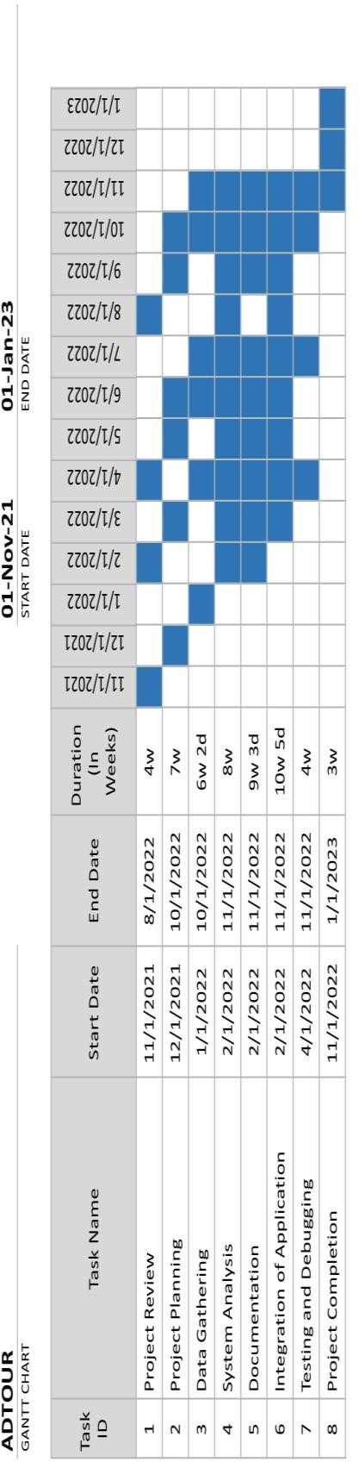

Appendix F

Data Dictionary

Table Name: Location data

|  |  |  |  |
| --- | --- | --- | --- |
| **Column** | **Data Type** | **Length** | **Null** |
| category_ID (*Primary*) | int | 22 | No |
| destination_ID | int | 28 | No |

Table Name: Category

|  |  |  |  |
| --- | --- | --- | --- |
| **Column** | **Data Type** | **Length** | **Null** |
| category_ID (*Primary*) | int | 11 | No |
| Cultural | varchar | 17 | No |
| Manmade | varchar | 17 | No |
| special_interest | varchar | 17 | No |

Table Name: Destination

|  |  |  |  |
| --- | --- | --- | --- |
| **Column** | **Data Type** | **Length** | **Null** |
| destination_ID (*Primary*) | int | 22 | No |
| Comment | varchar | 27 | No |
| Description | varchar | 27 | No |
| image_URL | object | 27 | No |

|  |  |  |  |
| --- | --- | --- | --- |
| Longitude | Int | 27 | No |
| Latitude | Int | 27 | No |
| Location | Varchar | 27 | No |
| Name | Varchar | 27 | No |

Table Name: Check-in

|  |  |  |  |
| --- | --- | --- | --- |
| **Column** | **Data Type** | **Length** | **Null** |
| user_ID (*Primary*) | int | 11 | No |
| destination_ID | int | 22 | No |
| time_stamp | int | 22 | No |

Table Name: User

|  |  |  |  |
| --- | --- | --- | --- |
| **Column** | **Data Type** | **Length** | **Null** |
| user_ID (*Primary*) | int | 11 | No |
| Age | int | 17 | No |
| first_name | varchar | 17 | No |
| last_name | varchar | 17 | No |
| Gender | varchar | 17 | No |
| phone_number | int | 17 | No |
| tourist_type | varchar | 17 | No |

Table Name: Feedback

|  |  |  |  |
| --- | --- | --- | --- |
| **Column** | **Data Type** | **Length** | **Null** |
| feedback_ID (*Primary*) | int | 28 | No |
| Comment | varchar | 33 | No |

Table Name: Admin

|  |  |  |  |
| --- | --- | --- | --- |
| **Column** | **Data Type** | **Length** | **Null** |
| admin_ID (*Primary*) | int | 6 | No |
| Analytics | varchar | 11 | No |
| users | varchar | 11 | No |

Appendix G

Entity-Relationship Diagram

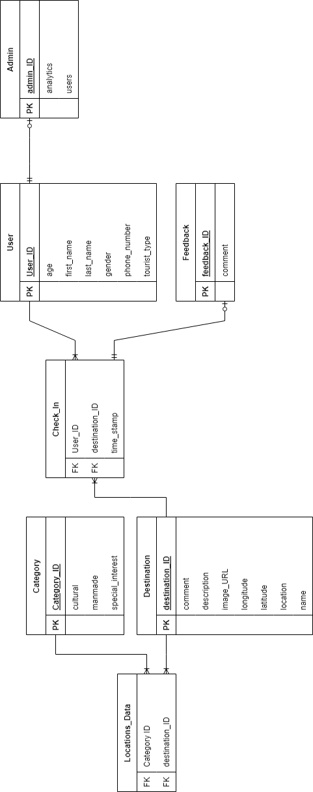

Appendix H

Sample Program Code

import 'dart:async'; import 'dart:math';

import 'package:android_app/widgets/configuration.dart'; import 'package:android_app/widgets/map/mapbox_widget.dart'; import 'package:android_app/widgets/newsfeed/cultural.dart'; import 'package:android_app/widgets/newsfeed/destination_confirmat ion.dart';

import 'package:android_app/widgets/newsfeed/manmade.dart'; import 'package:android_app/widgets/newsfeed/special_interest.dart ';

import 'package:android_app/widgets/profile/profile_picture_view_w idget.dart';

import 'package:android_app/widgets/splash_screen.dart'; import 'package:cloud_firestore/cloud_firestore.dart'; import 'package:firebase_analytics/firebase_analytics.dart'; import 'package:firebase_auth/firebase_auth.dart'; import 'package:flutter/material.dart';

import 'package:flutter/services.dart'; import

'package:flutter_speed_dial/flutter_speed_dial.dart'; import 'package:font_awesome_flutter/font_awesome_flutter.dart'; import 'package:google_fonts/google_fonts.dart';

import 'package:location/location.dart';

import 'package:maps_toolkit/maps_toolkit.dart';

class HomeWidget extends StatefulWidget {

const HomeWidget({Key? key}) : super(key: key);

@override

State<HomeWidget> createState() => _HomeWidgetState();

}

class _HomeWidgetState extends State<HomeWidget> { final User user = FirebaseAuth.instance.currentUser!; Map<String, dynamic> userData = {'profile_url': null}; List<QueryDocumentSnapshot> destinationInfos =

<QueryDocumentSnapshot>[];

List<LatLng> destinationPositions = <LatLng>[]; Map<String, dynamic>? closestLocation;

Timer? timer;

ValueNotifier<bool> isDialOpen = ValueNotifier(false);

Future<void> getLocations() async { CollectionReference culturalRef =

FirebaseFirestore.instance

.collection('LocationsData')

.doc("cultural")

.collection("destinations");

QuerySnapshot querySnapshot = await culturalRef.get();

// Get data from docs and convert map to List final culturalDesinations =

querySnapshot.docs.map((doc) {

Map<String, dynamic> data = doc.data() as Map<String, dynamic>;

if (mounted) { setState(() {

destinationInfos.add(doc);

});

}

return LatLng( double.parse(data['latitude']),

double.parse(data['longitude']));

}).toList();

CollectionReference manmadeRef = FirebaseFirestore.instance

.collection('LocationsData')

.doc("manmade")

.collection("destinations");

querySnapshot = await manmadeRef.get();

// Get data from docs and convert map to List

final manmadeDesinations = querySnapshot.docs.map((doc)

{

Map<String, dynamic> data = doc.data() as Map<String,

dynamic>;

if (mounted) { setState(() {

destinationInfos.add(doc);

});

}

return LatLng( double.parse(data['latitude']),

double.parse(data['longitude']));

}).toList();

CollectionReference specialinterestRef = FirebaseFirestore.instance

.collection('LocationsData')

.doc("manmade")

.collection("destinations");

querySnapshot = await specialinterestRef.get();

// Get data from docs and convert map to List final specialinterestDesinations =

querySnapshot.docs.map((doc) {

Map<String, dynamic> data = doc.data() as Map<String, dynamic>;

if (mounted) { setState(() {

destinationInfos.add(doc);

});

}

return LatLng( double.parse(data['latitude']),

double.parse(data['longitude']));

}).toList();

final allData =

culturalDesinations + manmadeDesinations + specialinterestDesinations;

if (mounted) { setState(() {

destinationPositions = allData;

});

}

}

Future<void> getUserLocation() async { if (destinationPositions.isEmpty) {

return;

}

Location location = Location();

bool serviceEnabled; PermissionStatus permissionGranted; LocationData locationData;

serviceEnabled = await location.serviceEnabled(); if (!serviceEnabled) {

serviceEnabled = await location.requestService(); if (!serviceEnabled) {

return;

}

}

permissionGranted = await location.hasPermission();

if (permissionGranted == PermissionStatus.denied) { permissionGranted = await

location.requestPermission();

if (permissionGranted != PermissionStatus.granted) { return;

}

}

locationData = await location.getLocation(); LatLng locationPosition =

LatLng(locationData.latitude!, locationData.longitude!);

num closestPosition = 100000000; int closestPositionIndex = 0;

destinationPositions.asMap().forEach((index, value) { num distance =

SphericalUtil.computeDistanceBetween(locationPosition, value);

closestPosition = min(closestPosition, distance); if (closestPosition == distance) {

closestPositionIndex = index;

}

});

Map<String, dynamic> destinationData = destinationInfos[closestPositionIndex - 1].data()

as Map<String, dynamic>;

LatLng destinationPosition = destinationPositions[closestPositionIndex];

setState(() { closestLocation = {

'location_name': destinationData['name'], 'distance': closestPosition / 1000, 'data': destinationData,

'id': destinationInfos[closestPositionIndex -

1].id,

1]

'latitude': destinationPosition.latitude, 'longitude': destinationPosition.longitude, 'comments': destinationInfos[closestPositionIndex -

.reference

.collection('comments')

};

});

}

void checkConfigured() {

if (userData['tourist_type'] == null) { timer!.cancel(); Navigator.pushReplacement(

context, MaterialPageRoute(

builder: (context) => ConfigurationWidget( uid: user.uid,

)));

}

}

@override

void initState() { FirebaseAnalytics.instance.logLogin().then((value) {}); FirebaseAnalytics.instance.logScreenView(screenName:

"Home");

FirebaseAnalytics.instance

.setUserId(id: FirebaseAuth.instance.currentUser?.uid);

DateTime today = DateTime.now(); print("${today.year}-${today.month}-${today.day}"); FirebaseFirestore.instance

.collection('users')

.doc(user.uid)

.get()

.then((data) {

setState(() {

userData = data.data()!;

});

checkConfigured();

});

FirebaseFirestore.instance

.collection('admin')

.doc('analytics')

.get()

.then((analyticsReference) { Map<String, dynamic> data = {};

if (analyticsReference.data() != null) {

data = analyticsReference.data() as Map<String, dynamic>;

}

if (data['logins'] != null) { data['logins'] += 1;

} else { data['logins'] = 1;

}

FirebaseFirestore.instance

.collection('admin')

.doc('analytics')

.set(data, SetOptions(merge: true))

.then((value) { FirebaseFirestore.instance

.collection('admin')

.doc('analytics')

.collection('logins')

.doc("${today.year}-${today.month}-

${today.day}")

.get()

.then((analyticsReference) { Map<String, dynamic> data = {};

if (analyticsReference.data() != null) {

data = analyticsReference.data() as Map<String,

dynamic>;

}

if (data['logins'] != null) { data['logins'] += 1;

} else { data['logins'] = 1;

}

FirebaseFirestore.instance

.collection('admin')

.doc('analytics')

.collection('logins')

.doc("${today.year}-${today.month}-

${today.day}")

});

});

});

.set(data, SetOptions(merge: true));

getLocations();

timer = Timer.periodic(

const Duration(seconds: 5), (Timer t) => getUserLocation());

super.initState();

}

void signOut() { timer!.cancel();

FirebaseAuth.instance.signOut();

}

@override

Widget build(BuildContext context) { return Scaffold(

appBar: AppBar( automaticallyImplyLeading: false,

backgroundColor: const Color.fromARGB(0, 255, 255,

255),

elevation: 0,

toolbarHeight: 80,

systemOverlayStyle: SystemUiOverlayStyle.light, title: GestureDetector(

onTap: () { Navigator.push(

context, MaterialPageRoute(

builder: (context) => ProfilePictureView( profileURL: userData['profile_url']

??

"https://t3.ftcdn.net/jpg/03/46/83/96/360_F_346839683_6nAPz bhpSkIpb8pmAwufkC7c5eD7wYws.jpg"),

));

},

child: CircleAvatar( child: ClipOval(

child: userData['profile_url'] == null

? Image.network( width: 100,

height: 100,

"https://t3.ftcdn.net/jpg/03/46/83/96/360_F_346839683_6nAPz bhpSkIpb8pmAwufkC7c5eD7wYws.jpg",

fit: BoxFit.cover,

)

: Image.network( userData['profile_url'], fit: BoxFit.cover, width: 100,

height: 100,

),

),

),

),

actions: [ IconButton(

onPressed: signOut, icon: const

FaIcon(FontAwesomeIcons.arrowRightFromBracket), color: Colors.amber[500], iconSize: 19,

)

],

),

body: Stack( children: [

Padding(

padding: const EdgeInsets.only(left: 15, top: 30, right: 15),

child: Column(

crossAxisAlignment: CrossAxisAlignment.start, children: [

Text(

"Explore",

style: GoogleFonts.nunitoSans(

FontWeight.w600),

),

fontSize: 40, fontWeight:

Expanded(

child: GridView.count( primary: false,

padding: const EdgeInsets.all(20), crossAxisSpacing: 10,

mainAxisSpacing: 10,

crossAxisCount: 2, children: [

GestureDetector( onTap: () {

Navigator.push( context, MaterialPageRoute(

builder: (context) => const

CulturalNewsfeedWidget()));

},

child: Container( alignment:

Alignment.bottomCenter,

decoration: const BoxDecoration( borderRadius:

BorderRadius.all(Radius.circular(10)),

image: DecorationImage( fit: BoxFit.cover, image: AssetImage(

'assets/cultural_background.jpg'))),

child: FractionallySizedBox( widthFactor: 1,

child: Container( decoration: const

BoxDecoration(

Color.fromARGB(200, 255, 255, 255),

BorderRadius.only(

Radius.circular(10), Radius.circular(10))),

color: borderRadius:

bottomLeft: bottomRight:

Alignment.center,

TextStyle(fontSize: 17),

height: 30, alignment:

child: const Text( "Cultural", style:

)),

),

),

),

GestureDetector( onTap: () {

Navigator.push( context, MaterialPageRoute(

builder: (context) => const

ManMadeNewsfeedWidget()));

},

child: Container( alignment:

Alignment.bottomCenter,

decoration: const BoxDecoration( borderRadius:

BorderRadius.all(Radius.circular(10)),

image: DecorationImage( fit: BoxFit.cover, image: AssetImage(

'assets/manmade_background.jpg'))),

child: FractionallySizedBox( widthFactor: 1,

child: Container( decoration: const

BoxDecoration(

Color.fromARGB(200, 255, 255, 255),

BorderRadius.only( Radius.circular(10), Radius.circular(10))),

color: borderRadius:

bottomLeft: bottomRight:

Alignment.center,

TextStyle(fontSize: 17),

),

),

height: 30, alignment:

child: const Text( "Man Made", style:

)),

),

GestureDetector( onTap: () {

Navigator.push(

context, MaterialPageRoute(

builder: (context) => const

SpecialInterestNewsfeedWidget()));

},

child: Container( alignment:

Alignment.bottomCenter,

decoration: const BoxDecoration( borderRadius:

BorderRadius.all(Radius.circular(10)),

image: DecorationImage( fit: BoxFit.cover, image: AssetImage(

'assets/manmade_background.jpg'))),

child: FractionallySizedBox( widthFactor: 1,

child: Container( decoration: const

BoxDecoration(

Color.fromARGB(200, 255, 255, 255),

BorderRadius.only( Radius.circular(10),

Radius.circular(10))),

color: borderRadius:

bottomLeft: bottomRight:

Alignment.center,

TextStyle(fontSize: 17),

),

),

height: 30, alignment:

child: const Text( "Special Interest", style:

)),

),

],

),

)

// Expanded(child: ListView.builder(itemBuilder: ((context, index) {

// }),))

],

),

),

Positioned(

bottom: 0,

left: 0,

child: GestureDetector( onTap: () {

if (closestLocation != null) { Navigator.push(

context, MaterialPageRoute(

builder: (context) => DestinationConfirmationWidget(

closestLocation!['data'],

closestLocation!['comments'])));

}

},

child: Card(

data:

id: closestLocation!['id'], collectionReference:

child: Padding(

padding: const EdgeInsets.all(8.0), child: Container(

width: 200, child: Column(

children: [

...(closestLocation != null

? [

closestLocation!["location_name"], TextStyle(fontSize: 20), TextOverflow.ellipsis,

]

Text(

style: overflow:

)

: []),

Text(

"Closest Location${closestLocation != null ? " (${(closestLocation!["distance"] as num).toStringAsFixed(1)} km)" : ""}",

style: TextStyle(

fontSize: 15, fontWeight:

FontWeight.bold),

),

],

),

),

),

Appendix I ISO Questionnaire

Using the scale below evaluate the system by placing a check (✔) mark on the appropriate column.

5– Very Good 4- Good 3- Fair 2- Poor 1- Very Poor

1. Functional Stability

|  |  |  |  |  |  |  |
| --- | --- | --- | --- | --- | --- | --- |
| **Indicators** | | **5** | **4** | **3** | **2** | **1** |
| Completeness | The set of instructions all the specified task  and user objectives. |  |  |  |  |  |
| Correctness | The system provides correct results with the needed degree of precision. |  |  |  |  |  |
| Appropriateness | The system provides the accomplishment of specified tasks and objectives. |  |  |  |  |  |

1. Reliability

|  |  |  |  |  |  |  |
| --- | --- | --- | --- | --- | --- | --- |
| **Indicators** | | **5** | **4** | **3** | **2** | **1** |
| Maturity | A system, product or component meets for reliability under normal operation. |  |  |  |  |  |

|  |  |  |  |  |  |  |
| --- | --- | --- | --- | --- | --- | --- |
| Availability | A product or system is operational and accessible when required for use |  |  |  |  |  |
| Fault tolerance | A system, product, or component operates as intended despite the presence of hardware or software results. |  |  |  |  |  |
| Recoverability | In the event of an interruption or a failure, a product or system can recover the data and establish the desired state of the system. |  |  |  |  |  |

1. Portability

|  |  |  |  |  |  |  |
| --- | --- | --- | --- | --- | --- | --- |
| **Indicators** | | **5** | **4** | **3** | **2** | **1** |
| Adaptability | A product or system can effectively and efficiently be adapted for different or evolving hardware, software or other operational or usage environments. |  |  |  |  |  |
| Durability | A product or system can withstand technology evolution and changes without costly redesign, reconfiguration or recording. |  |  |  |  |  |
| Installability | A product or system can be successfully installed and/or uninstalled in a specified environment. |  |  |  |  |  |

|  |  |  |  |  |  |  |
| --- | --- | --- | --- | --- | --- | --- |
| Replaceability | A product can replace another specified software product for the same purpose in the same environment. |  |  |  |  |  |
| Affordability | A product or system can increase efficiency and productivity by reducing the time and costs involved in delivering instruction |  |  |  |  |  |

1. Usability

|  |  |  |  |  |  |  |
| --- | --- | --- | --- | --- | --- | --- |
| **Indicators** | | **5** | **4** | **3** | **2** | **1** |
| Appropriateness recognizability | Users can recognize whether a product or the system is appropriate for their needs |  |  |  |  |  |
| Learnability | A product or the system enables the user to learn how to use it with effectiveness, efficiency in emergency situations. |  |  |  |  |  |
| Operability | A product or system easy to operate, control and appropriate to use. |  |  |  |  |  |
| User error protection | A product or system protects users against making errors. |  |  |  |  |  |
| User interface aesthetics | A user interface enables pleasing and satisfying interactions for the user. |  |  |  |  |  |

|  |  |  |  |  |  |  |
| --- | --- | --- | --- | --- | --- | --- |
| Accessibility | A product or system can be used by people with the widest range of characteristics and capabilities to achieve a specified goal in a specified context of use. |  |  |  |  |  |

1. Performance Efficiency

|  |  |  |  |  |  |  |
| --- | --- | --- | --- | --- | --- | --- |
| **Indicators** | | **5** | **4** | **3** | **2** | **1** |
| Time-behavior | The response and processing time and throughput rates of a product or system when performing its functions, meet requirements. |  |  |  |  |  |
| Resource utilization | The amounts and types of resources used by a product or system, when performing its functions meet requirements. |  |  |  |  |  |
| Capacity | The maximum limits of the product or system parameters meet requirements. |  |  |  |  |  |

1. Security

|  |  |  |  |  |  |  |
| --- | --- | --- | --- | --- | --- | --- |
| **Indicators** | | **5** | **4** | **3** | **2** | **1** |
| Confidentiality | The prototype ensures that data are accessible only to |  |  |  |  |  |

|  |  |  |  |  |  |  |
| --- | --- | --- | --- | --- | --- | --- |
|  | those authorized to have access. |  |  |  |  |  |
| Integrity | A system, product, or component prevents unauthorized access to, or modification of, computer programs or data. |  |  |  |  |  |
| Non-repudiation | Actions or events can be proven to have taken place so that the events or actions cannot be repudiated later. |  |  |  |  |  |
| Accountability | The actions of an entity can be traced uniquely to the entity. |  |  |  |  |  |
| Authenticity | The identity of a subject or resources can be proved to be the one claimed. |  |  |  |  |  |

1. Compatibility

|  |  |  |  |  |  |  |
| --- | --- | --- | --- | --- | --- | --- |
| **Indicators** | | **5** | **4** | **3** | **2** | **1** |
| Co-existence | A product can perform its required functions efficiently while sharing a common environment and resources with other products, without detrimental impact on any other product. |  |  |  |  |  |
| Interoperability | The two or more systems, products or components can exchange information |  |  |  |  |  |

|  |  |  |  |  |  |  |
| --- | --- | --- | --- | --- | --- | --- |
|  | and use the information that has been exchanged. |  |  |  |  |  |

1. Maintainability

|  |  |  |  |  |  |  |
| --- | --- | --- | --- | --- | --- | --- |
| **Indicators** | |  |  |  |  |  |
| Modularity | The application is composed of discrete components such that a change to one component has minimal impact on other components. |  |  |  |  |  |
| Reusability | An asset can be used in more than the system, or in building other assets. |  |  |  |  |  |
| Analyzability | It is possible to assess the impact on a product or system of an intended change to one or more of its parts, or to diagnose a product for deficiencies or causes of failures, or to identify parts to be modified. |  |  |  |  |  |
| Modifiability | The application can be effectively and efficiently modified without introducing defects or degrading existing product quality. |  |  |  |  |  |
| Testability | Test criteria can be established for an application, product or component and tests can be performed to determine whether those criteria have been met. |  |  |  |  |  |

Appendix J Disclaimer

This software project and its corresponding documentation entitled “Crowdsourced-based Mobile Application with Sentiment Analysis for Local Tourist Attractions” is submitted to the College of Information and Communications Technology, West Visayas State University, in partial fulfillment of the requirements for the degree, Information Systems. It is the product of our own work, except where indicated text.

We hereby grant the College of Information and Communications Technology permission to freely use, publish in local or international journal/conferences, reproduce, or distribute publicly the paper and electronic copies of this software project and its corresponding documentation in whole or in part, provided that we are acknowledged.

Iviegel G. Cadiz Jhon Anthony R. Eleccion

Luke S. Gareza Rhean T. Magbanua Sigen Marc C. Miranda

June 2023